**Assignment # 2**

**Given Questions**

**1.** Write a program in C++. In this program you have to print your Name by using single cout statements. No variables needs to be declare in this program.

**2.** Write a program which takes input obtained marks and maximum marks of five subjects. After taking input you have to calculate percentage of obtained marks.

**3.** Assuming there are 7.481 gallons in a cubic foot, write a program that asks the user to enter a number of gallons, and then displays the equivalent in cubic feet. (10-Marks)

**4.** A library function, islower(), takes a single character (a letter) as an argument and returns a nonzero integer if the letter is lowercase, or zero if it is uppercase. This function requires the header file CTYPE.H. Write a program that allows the user to enter a letter, and then displays either zero or nonzero, depending on whether a lowercase or uppercase letter was entered. (10-Marks)

**5.** On a certain day the British pound was equivalent to $1.487 U.S., the French franc was $0.172, the German deutschemark was $0.584, and the Japanese yen was $0.00955. Write a program that allows the user to enter an amount in dollars, and then displays this value converted to these four other monetary units. (10-Marks)

**6.** If you have two fractions, a/b and c/d, their sum can be obtained from the formula Write a program that encourages the user to enter two fractions, and then displays their sum in fractional form. (You don’t need to reduce it to lowest terms.) The interaction with the user might look like this: Enter first fraction: 1/2 Enter second fraction: 2/5 Sum = 9/10 (10-Marks)

**7.** You found an exciting summer job for five weeks. It pays, say, $15.50 per hour. Suppose that the total tax you pay on your summer job income is 14%. After paying the taxes, you spend 10% of your net income to buy new clothes and other accessories for the next school year and 1% to buy school supplies. After buying clothes and school supplies, you use 25% of the remaining money to buy savings bonds. For each dollar you spend to buy savings bonds, your parents spend $0.50 to buy additional savings bonds for you. Write a program that prompts the user to enter the pay rate for an hour and the number of hours you worked each week. The program then outputs the following: a. Your income before and after taxes from your summer job. b. The money you spend on clothes and other accessories. c. The money you spend on school supplies. d. The money you spend to buy savings bonds. e. The money your parents spend to buy additional savings bonds for you (10-Marks)

**8.** Newton’s law states that the force, F, between two bodies of masses M1 and M2 is given by: in which k is the gravitational constant and d is the distance between the bodies. The value of k is approximately 6.67 x 10-8 dyn. cm2 /g2 . Write a program that prompts the user to input the masses of the bodies and the distance between the bodies. The program then outputs the force between the bodies. (10-Marks) **9.** One metric ton is approximately 2205 pounds. Write a program that prompts the user to input the amount of rice, in pounds, in a bag. The program outputs the number of bags needed to store one metric ton of rice. (10-Marks)

**10**. Shazooka uses the services of a brokerage firm to buy and sell stocks. The firm charges 1.5% service charges on the total amount for each transaction, buy or sell. When Shazooka sells stocks, she would like to know if she gained or lost on a particular investment. Write a program that allows Shazooka to input the number of shares sold, the purchase price of each share, and the selling price of each share. The program outputs the amount invested, the total service charges, amount gained or lost, and the amount received after selling the stock. (10-Marks)

**11.** Interest on a credit card’s unpaid balance is calculated using the average daily balance. Suppose that netBalance is the balance shown in the bill, payment is the payment made, d1 is the number of days in the billing cycle, and d2 is the number of days payment is made before billing cycle. Then, the average daily balance is: averageDailyBalance = (netBalance * d1 – payment * d2)/d1 If the interest rate per month is, say, 0.0152, then the interest on the unpaid balance is: interest = averageDailyBalance * 0:0152 Write a program that accepts as input netBalance, payment, d1, d2, and interest rate per month. The program outputs the interest. (10-Marks)

**12.** A box of cookies can hold 24 cookies, and a container can hold 75 boxes of cookies. Write a program that prompts the user to enter the total number of cookies, the number of cookies in a box, and the number of cookie boxes in a container. The program then outputs the number of boxes and the number of containers to ship the cookies. Note that each box must contain the specified number of cookies, and each container must contain the specified number of boxes. If the last box of cookies contains less than the number of specified cookies, you can discard it and output the number of leftover cookies. Similarly, if the last container contains less than the number of specified boxes, you can discard it and output the number of leftover boxes. (10-Marks)

**13.** The roots of the quadratic equation ax2 + bx + c = 0, a≠ 0 are given by the following formula: In this formula, the term b 2 - 4ac is called the discriminant. If b2 - 4ac = 0, then the equation has a single (repeated) root. If b2 - 4ac > 0, the equation has two real roots. If b2 -4ac < 0, the equation has two complex roots. Write a program that prompts the user to input the value of a (the coefficient of x2 ), b (the coefficient of x), and c (the constant term) and outputs the type of roots of the equation. Furthermore, if b2 -4ac = 0, the program should output the roots of the quadratic equation. (10-Marks) **14.** A bank in your town updates its customers’ accounts at the end of each month. The bank offers two types of accounts: savings and checking. Every customer must maintain a minimum balance. If a customer’s balance falls below the minimum balance, there is a service charge of $10.00 for savings accounts and $25.00 for checking accounts. If the balance at the end of the month is at least the minimum balance, the account receives interest as follows: a. Savings accounts receive 4% interest. b. Checking accounts with balances of up to $5,000 more than the minimum balance receive 3% interest; otherwise, the interest is 5%. Write a program that reads a customer’s account number (int type), account type (char; s for savings, c for checking), minimum balance that the account should maintain, and current balance. The program should then output the account number, account type, current balance, and an appropriate message. Test your program by running it five times, using the following data: (10-Marks)

**15.** Write a C program to read an amount (integer value) and break the amount into smallest possible number of bank notes. Note: The possible banknotes are 500, 100, 50, 20, 10, 5, 2, and 1 (10-Marks)

**16.** Write a program that inputs salary and grade. It adds 50% bonus if the grade is greater than 15. It adds 25% bonus if the grade is 15 or less and then display the total salary. (10-Marks)

**17.** Write a program that converts an integer e.g. 5 to its binary form. Print out binary in the following format: Enter decimal no: 5 Binary is: 101 (10-Marks)

**18.** Write a program that takes two numbers and an operation (+, -, *, /) as character from user as input and displays the result by using if else statements. (10-Marks)

**19.** Write a program that input an integer as an argument and returns Even if an even number and Odd if it is odd? (05-Marks)

**20.** Write a program that reads two integers and determines and prints if the first is a multiple of the second. (05-Marks)

**21.** Write a program to determine which character is entered by the user from the keyboard i.e., an uppercase character, a lowercase character, a digit or a special symbol. (05-Marks)

**22.** Write a program that inputs a five-digit number from the user, reverses it and determines if the original and reverse numbers are equal or not. Do not allow the user to enter any other number except a five-digit number. (05-Marks)

**23.** The final digit of a Universal Product Code is a check digit computed so that sum of the even positions number, plus 3 multiplies with the sum of odd positioned numbers, modulo 10 = 0. For example, in your program take the UPC as 7 digits number i.e. 4708874. The sum of even positioned digits is 7+8+7 = 22, and the sum of the odd-numbered digits is 4+0+8+4 = 16. The total sum is 22+3×16 = 70 = 0 modulo 10. So, the code is valid. (10-Marks)

**24.** Write a program which display the sum of whole part and decimal part of a float number Input decimal number = 7.8; Output => 15 (10-Marks)

**25.** Write a program which checks whether a character is an alphabet or not. (05-Marks)

26. Write a program which takes 4 different number from user as input and display them in ascending and descending order. (05-Marks)

**27.** Write a C++ program to read the age of a candidate and determine whether it is eligible for casting his/her own vote. (05-Marks)

**28.** Write a C program to accept a coordinate point in a XY coordinate system and determine in which quadrant the coordinate point lies. (05-Marks)

**29.** Write a program to find the eligibility of admission for a professional course based on the following criteria: Eligibility Criteria: Marks in Math’s >= 65 and Marks in Phy >=55 and Marks in Chem>=50 (05-Marks)

**30**. Write a C program to read roll no, name and marks of three subjects and calculate the total, percentage and division. (05-Marks)

**31.** Write a C program to read temperature in centigrade and display a suitable message according to temperature state below : Temp < 0 then Freezing weather Temp 0-10 then Very Cold weather Temp 10-20 then Cold weather Temp 20-30 then Normal in Temp Temp 30-40 then Its Hot Temp >=40 then Its Very Hot (10-Marks)

**32.** Write a C++ program to check whether a triangle is Equilateral, Isosceles or Scalene. (05-Marks)

**33.** Write a C++ program to check whether a triangle can be formed by the given value for the angles. **34.** Write a program to check whether a character is an alphabet, digit or special character. (05-Marks)

**35.** Write a program to read any digit from 0 to 9, display in the word. (05-Marks)

**36.** Write a program to check whether a number is divisible by 5 or 11. (05-Marks)

**37.** Write a program to find the largest among 3 using nested if. (05-Marks)

**38.** Write a menu based program for opening two formulas: (10-Marks) (a+b)^2 (a-b)^2 Example output Screen:

**39.** Write a program which will calculate the salary of an employ and detect 5% tax if its more than 50000. (10-Marks)

**40.** Write a program to calculate the electricity bill. The rates of electricity per unit are as follow: If the units consumed are equal or less than 300,then the cost is Rs. 3/- per unit If units consumed are more than 300,then the cost is Rs. 3.5/- per unit (10-Marks

**Solved Answers**

**Assignment # 2**

**Program # 1 (Code) :**

Coding form of the program 1 :

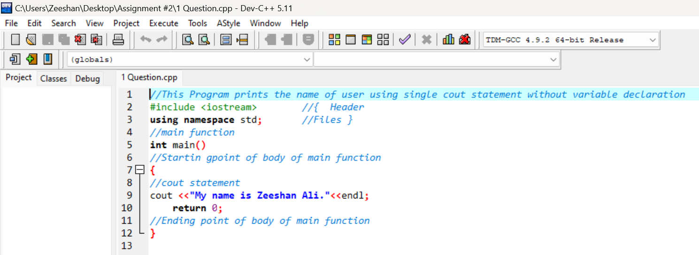

**Program # 1 ( Output) :**

Output of the program 1 on the console

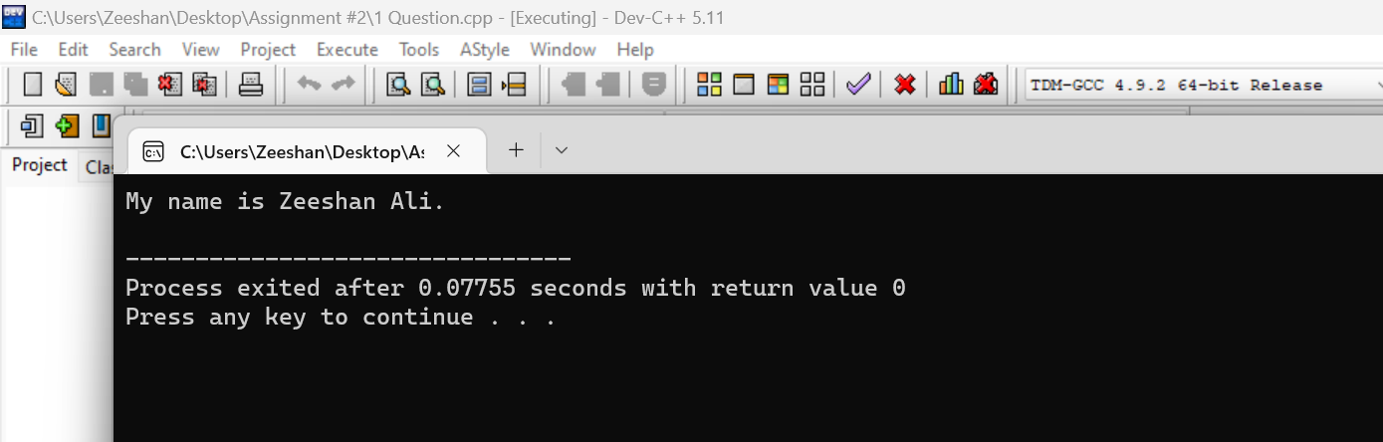

**Program # 2 (Code)**

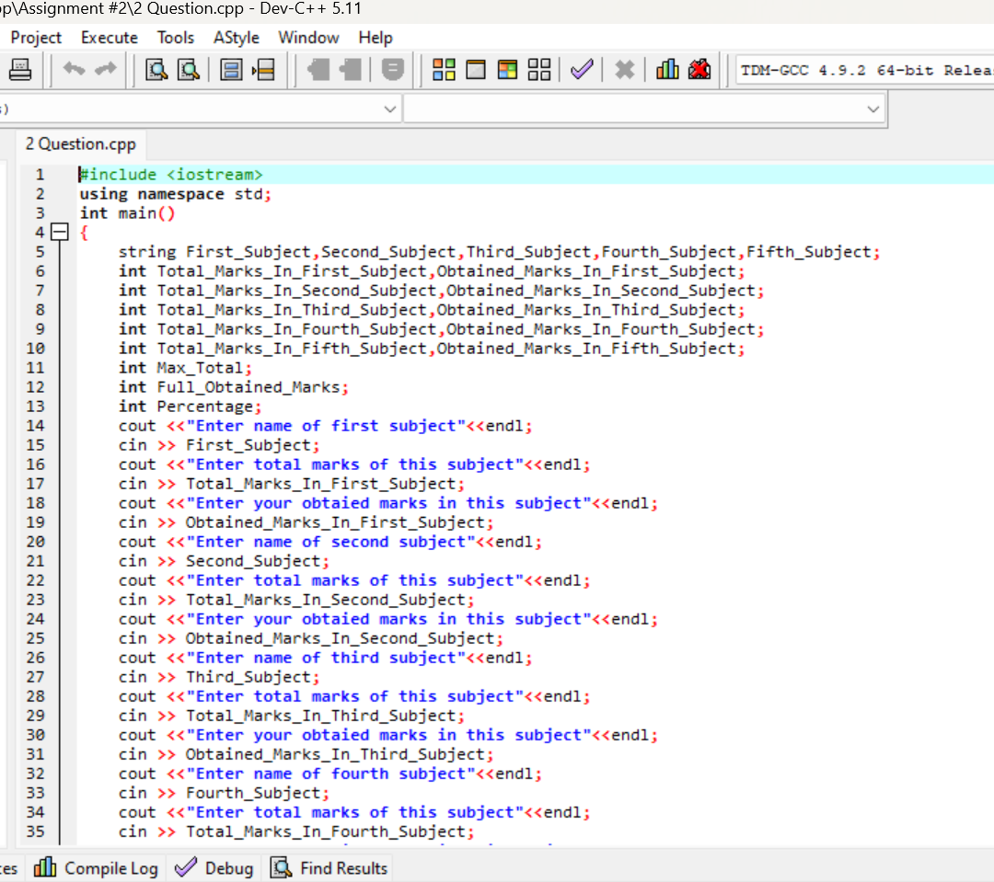

**Another …….**

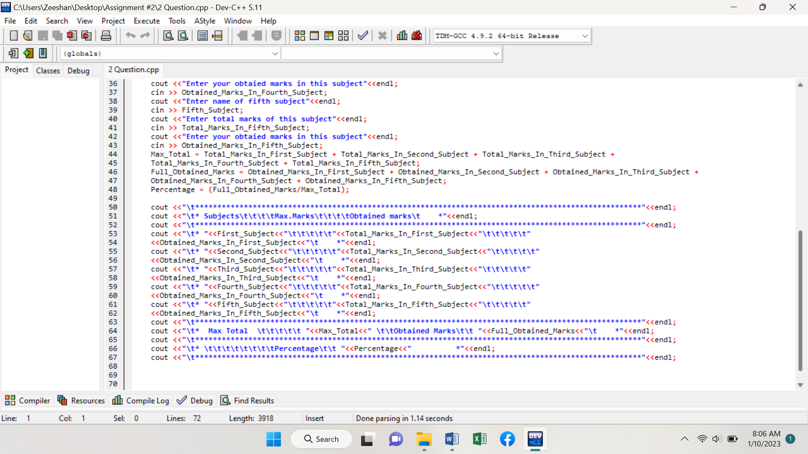

**Program # 2 (Output)**

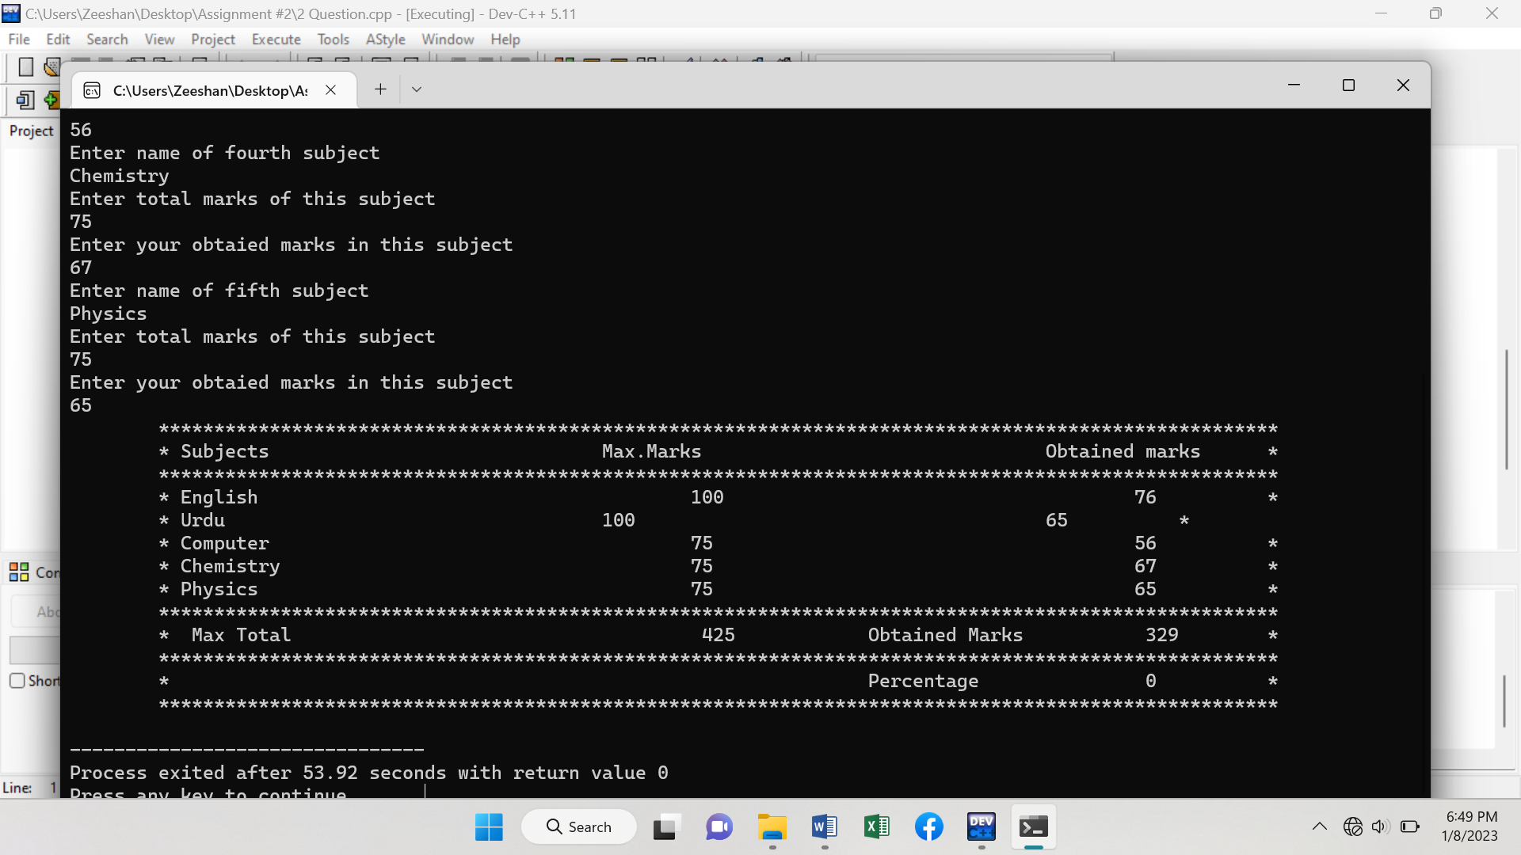

**Program # 3 (Code)**

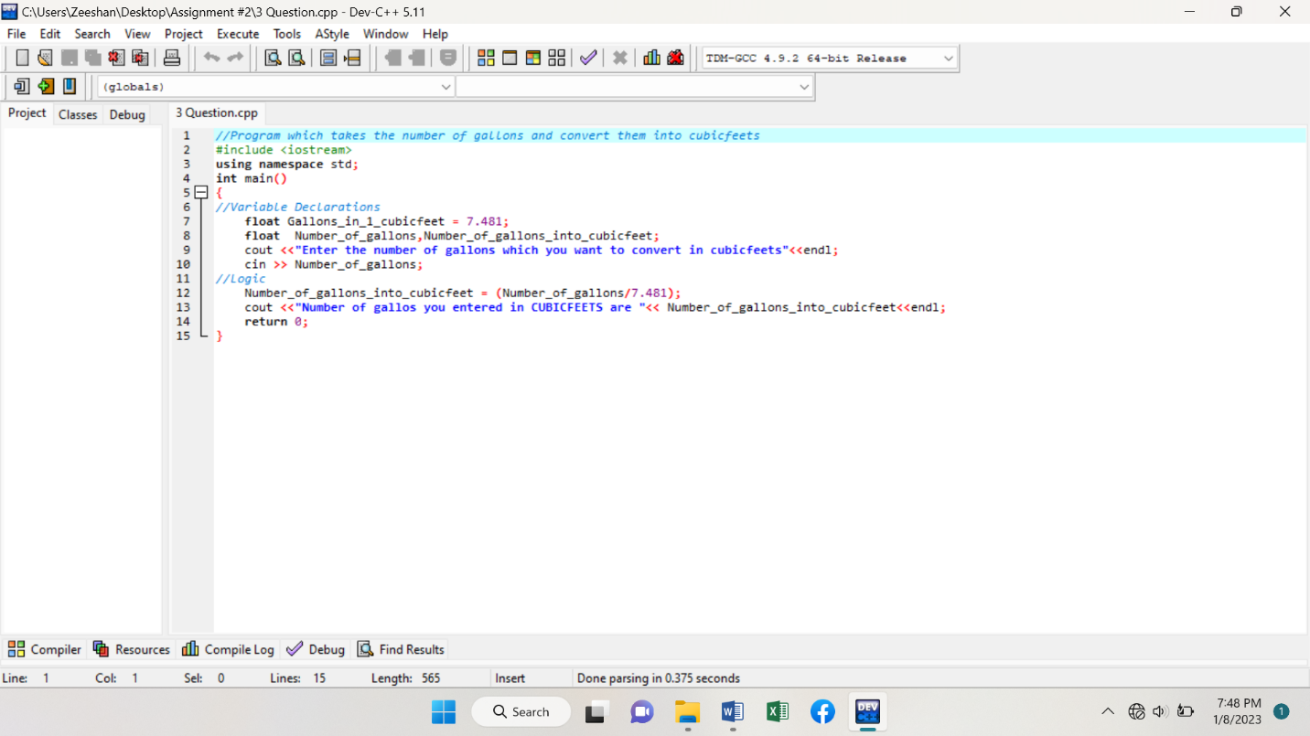

**Program # 3 (Output)**

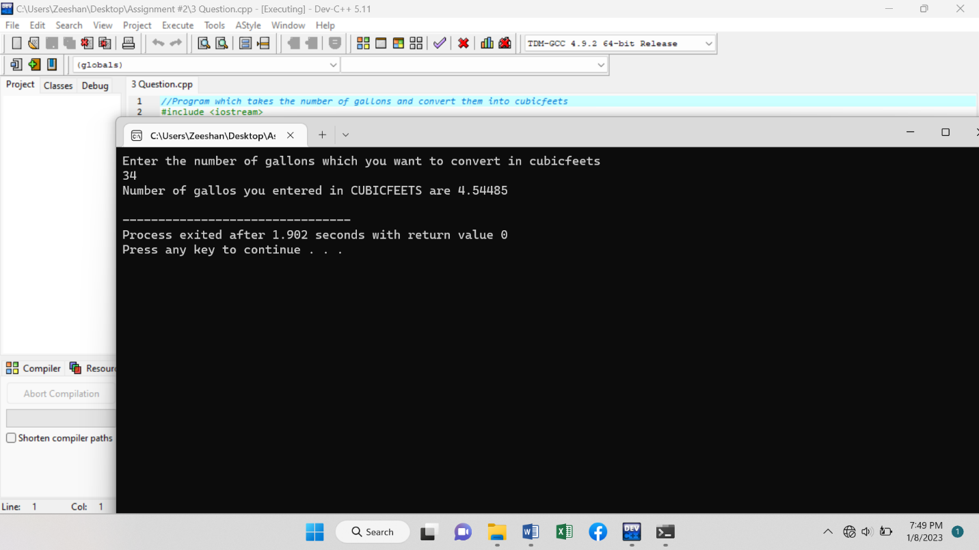

**Program # 4 (Code)**

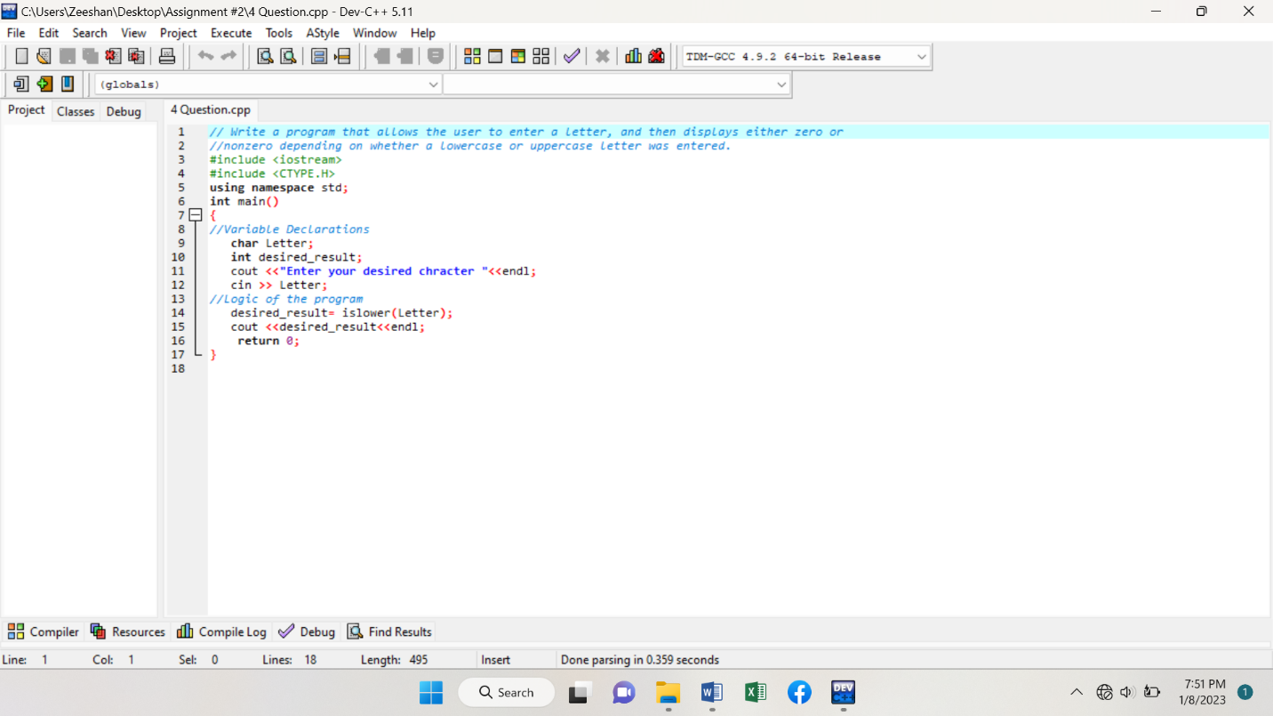

**Program # 4 (Output)**

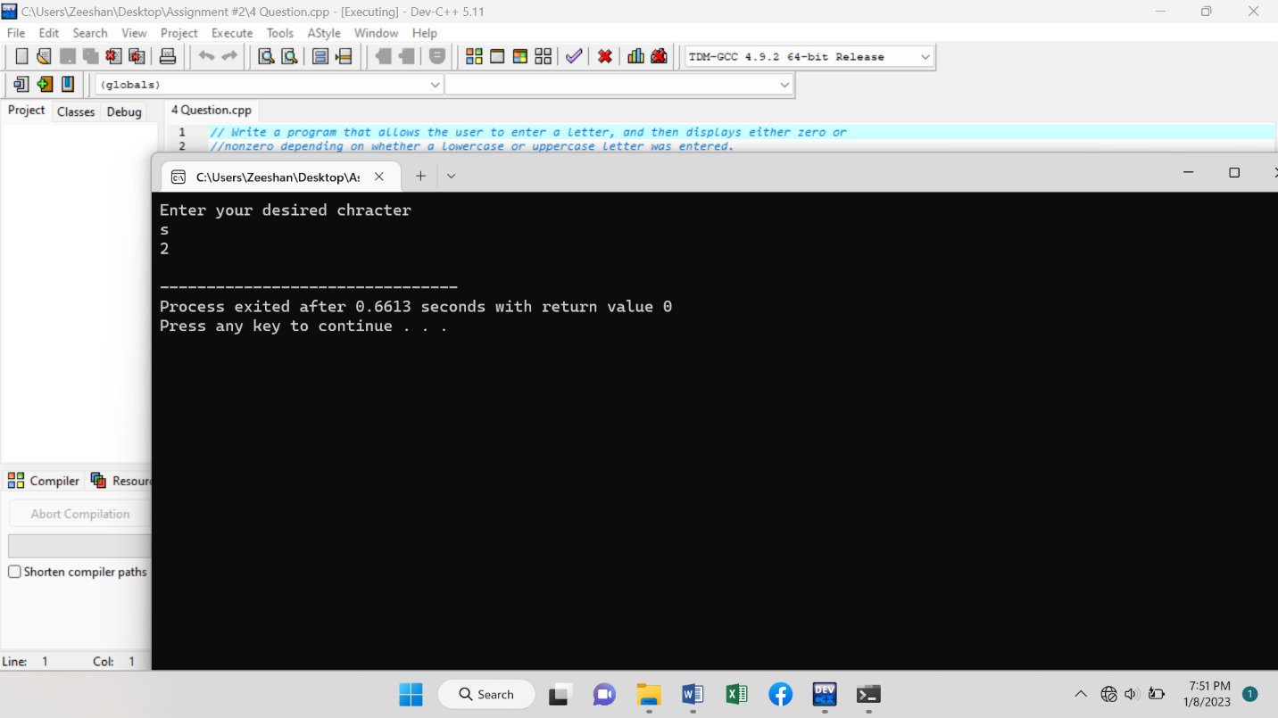

**Program # 5 (Code)**

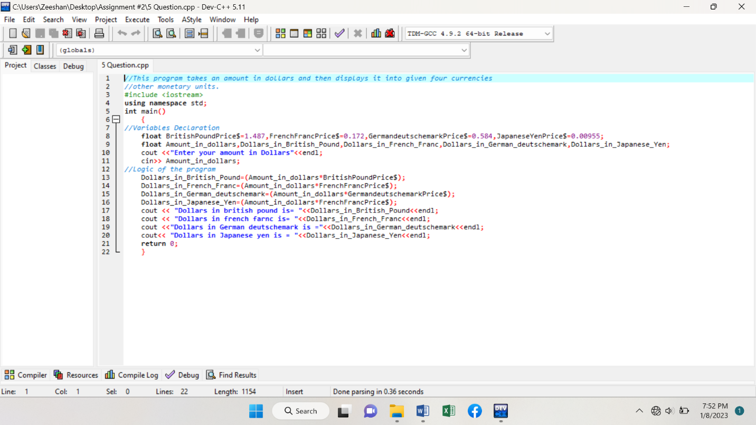

**Program # 5 (Output)**

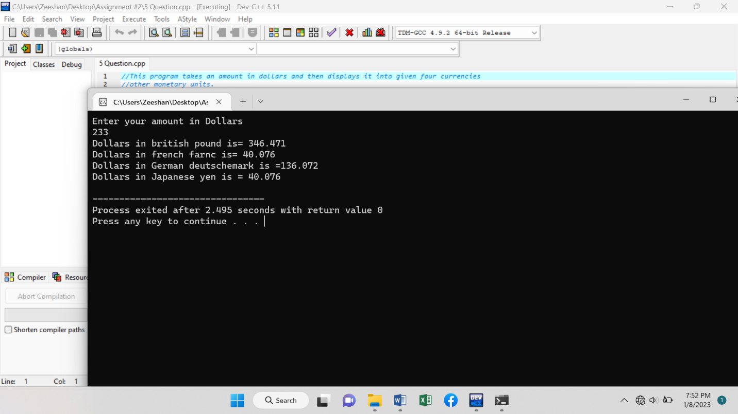

**Program # 6 (Code)**

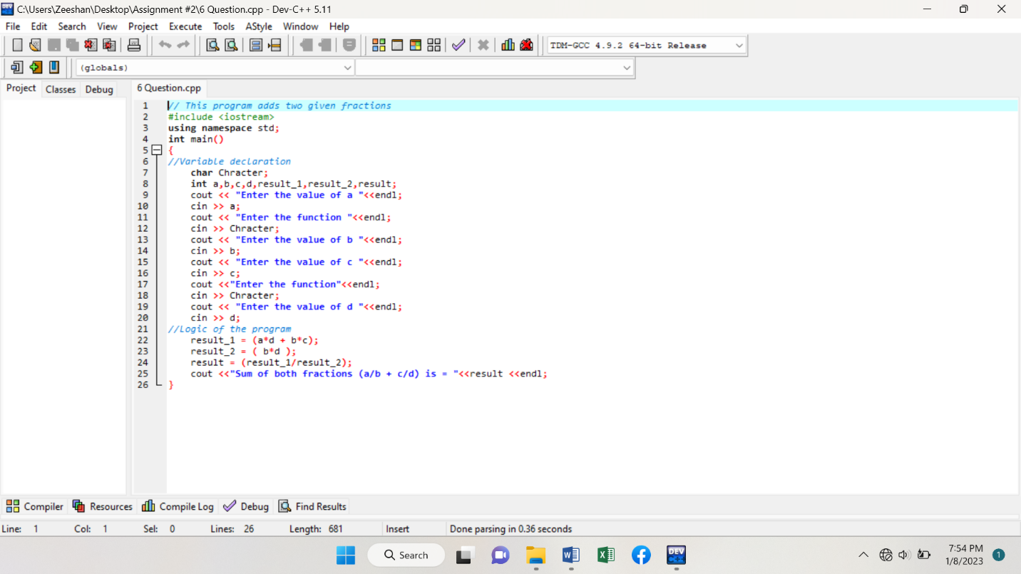

**Program # 6 (Output)**

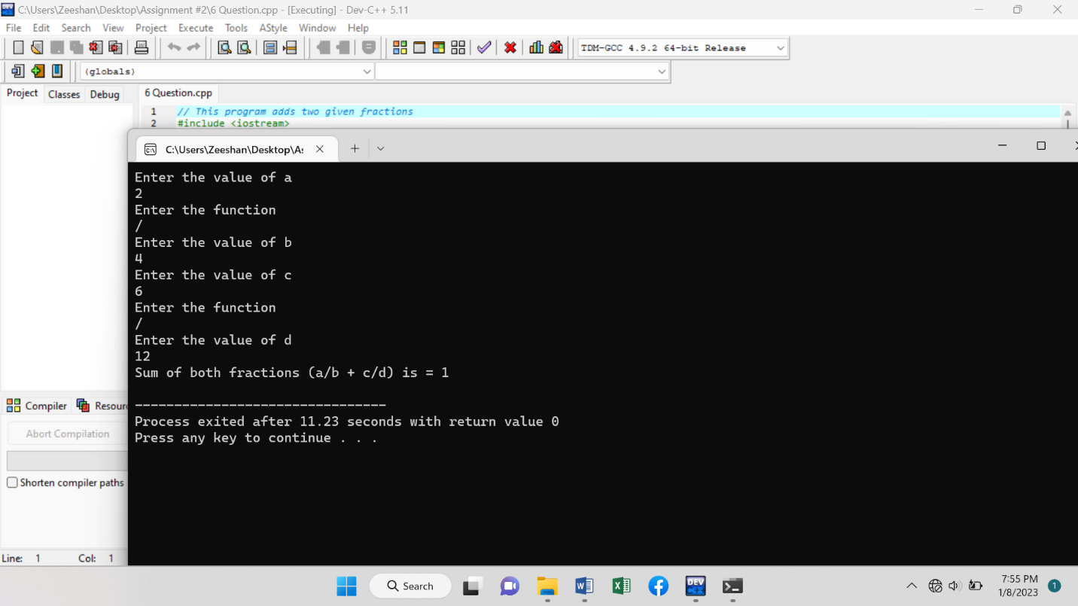

**Program # 7 (Code)**

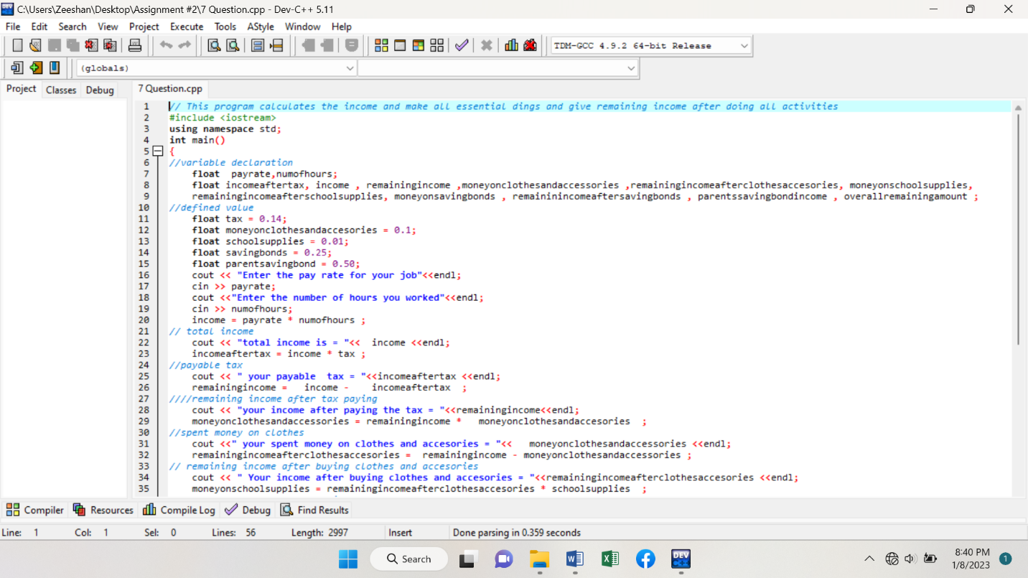

**Another …………**

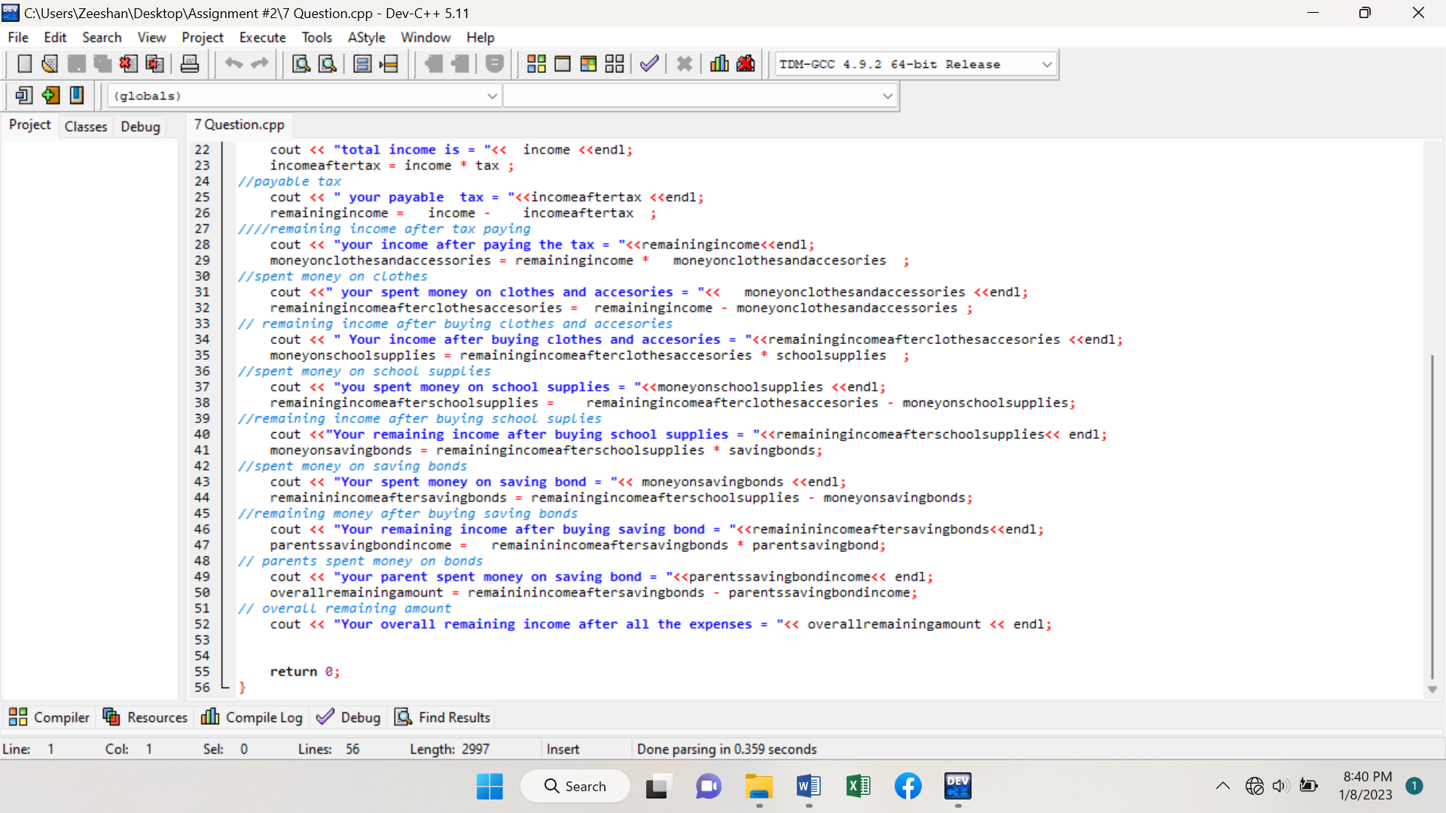

**Program # 7 (Output)**

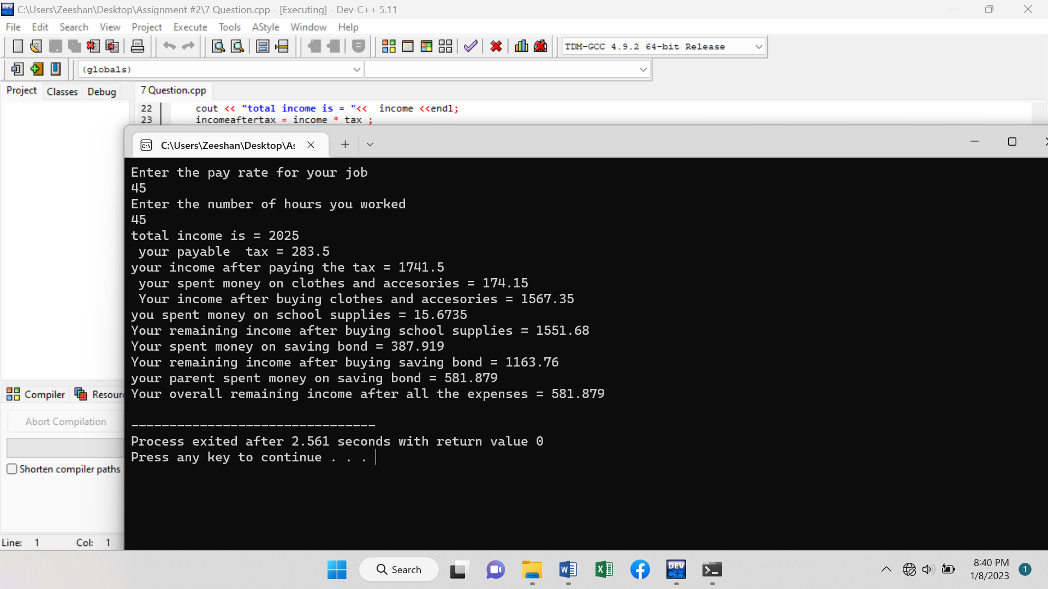

**Program # 8 (Code)**

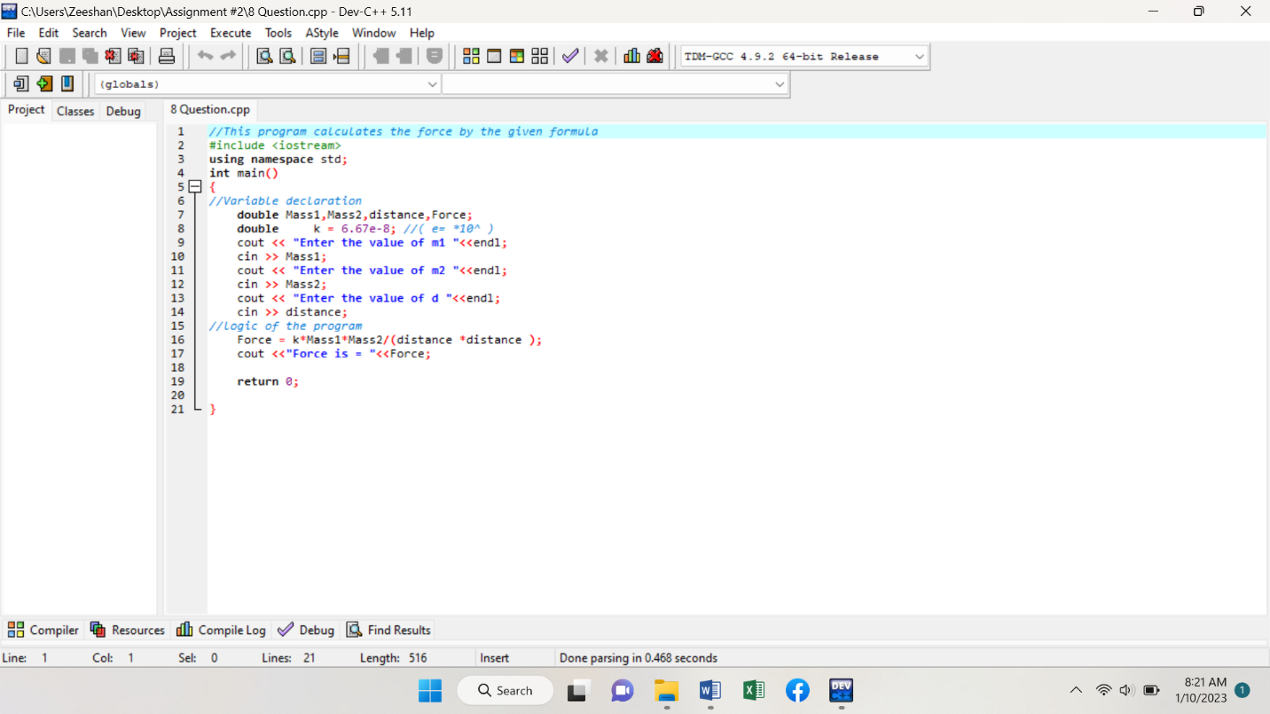

**Program # 8 (Output)**

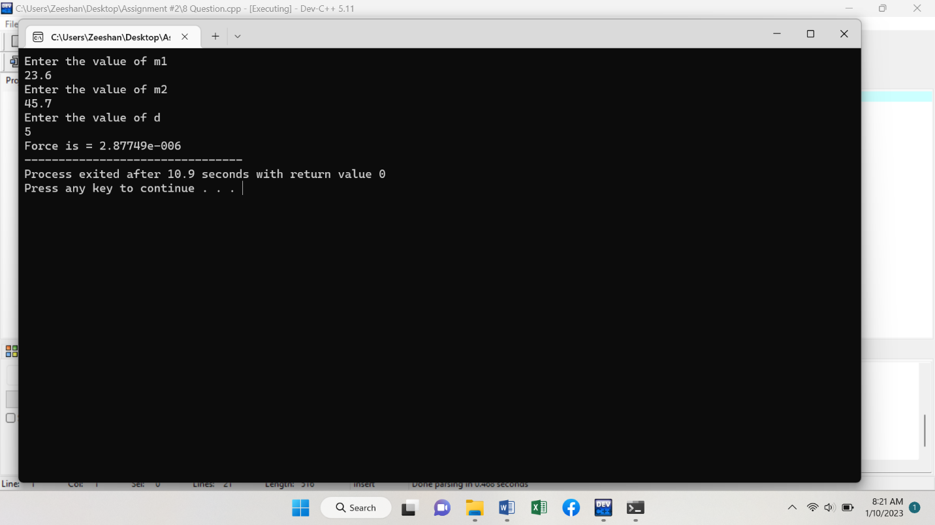

**Program # 9 (Code)**

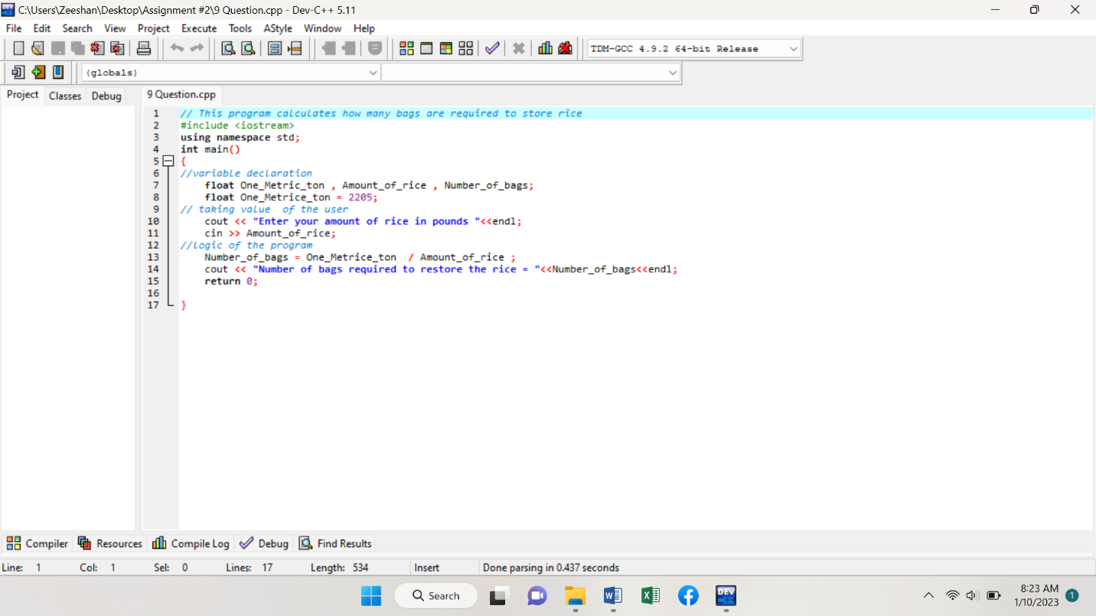

**Program # 9 (Output)**

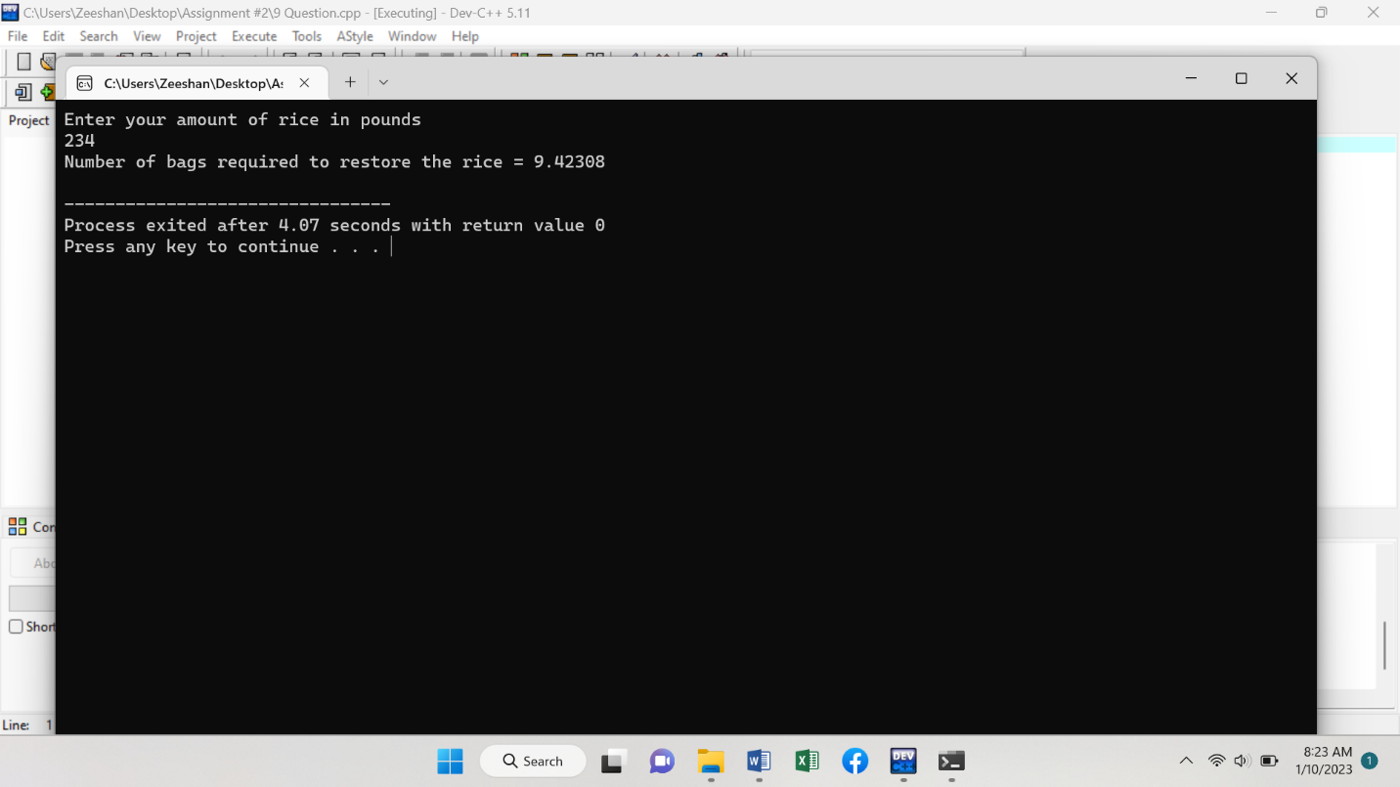

**Program # 10 (Code)**

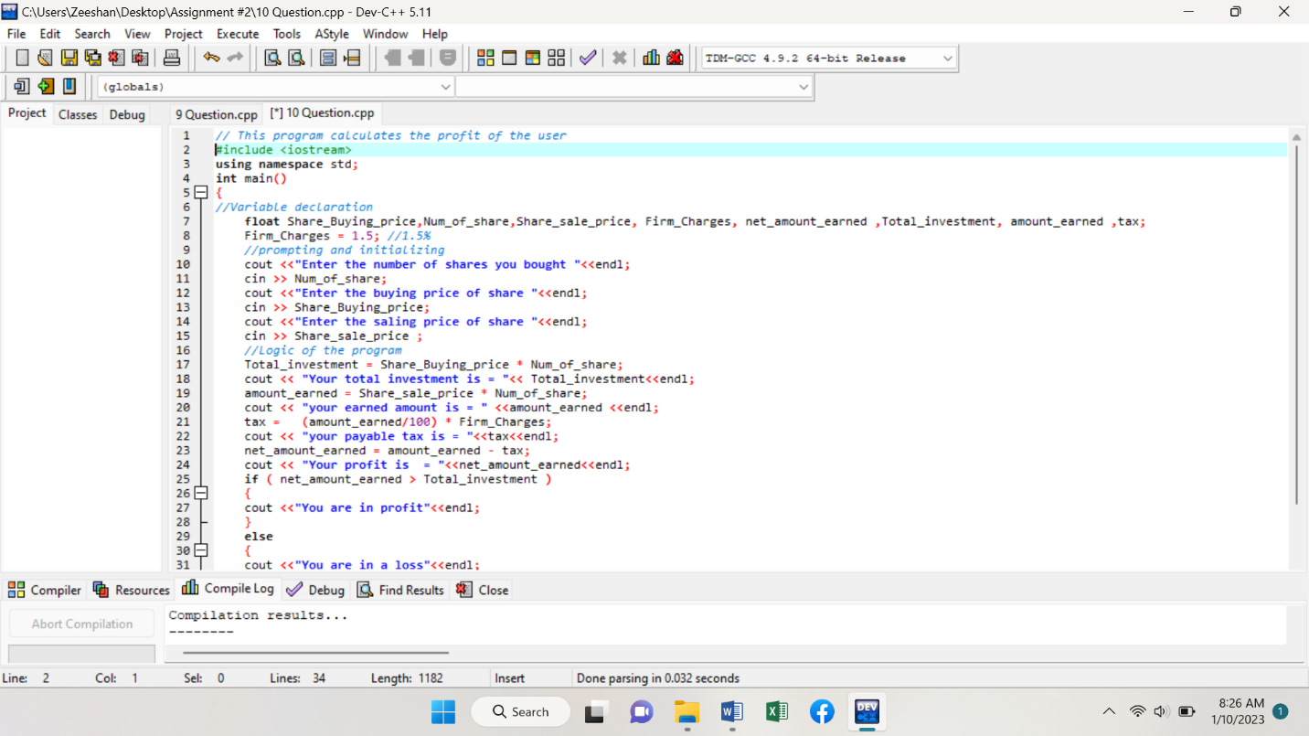

**Another …………**

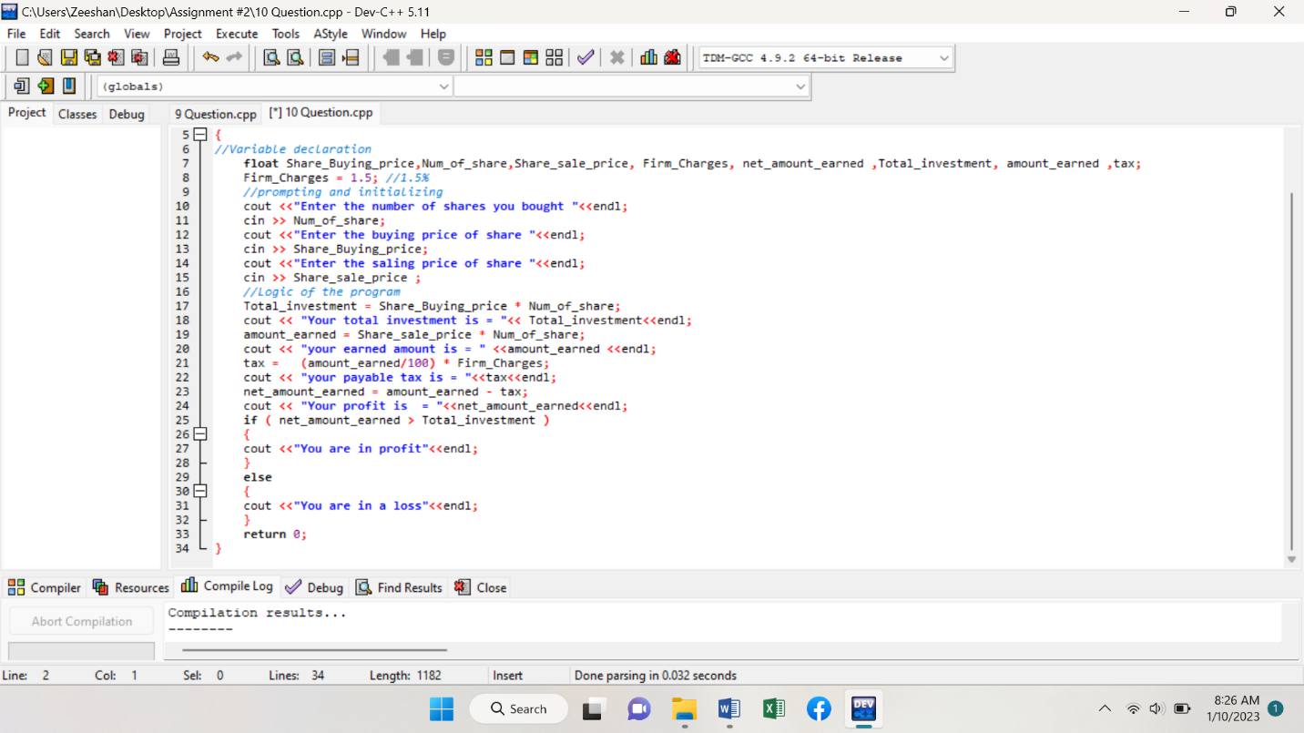

**Program # 10 (Output)**

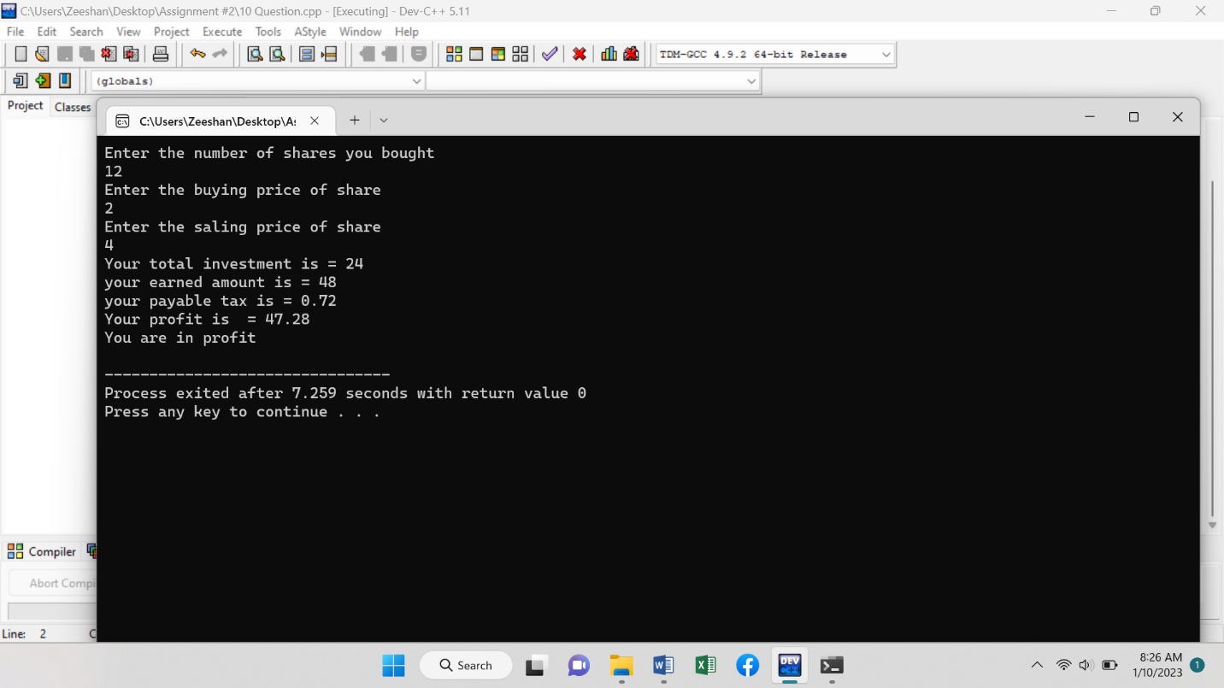

**Program # 11 (Code)**

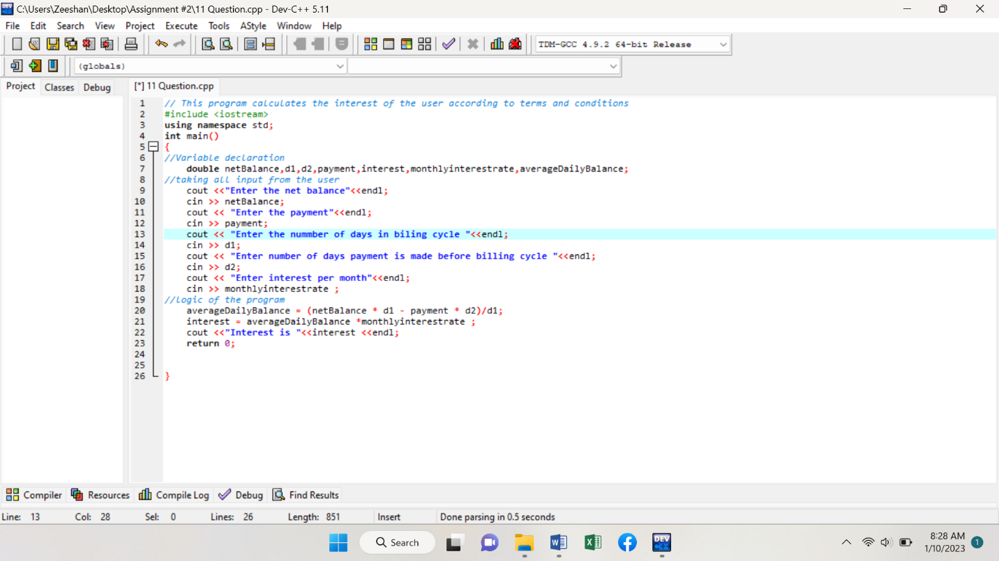

**Program # 11 (Output)**

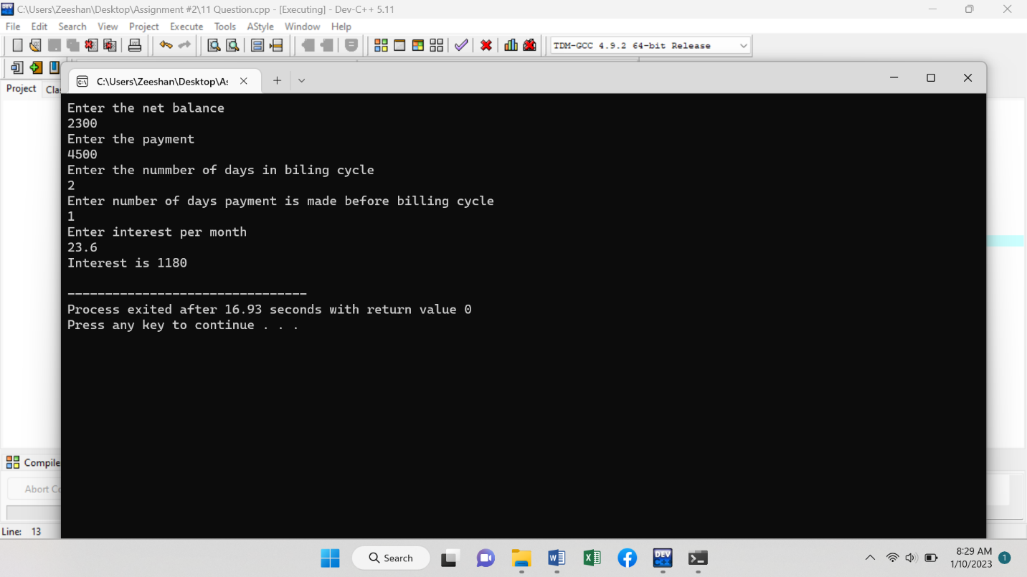

**Program # 12 (Code)**

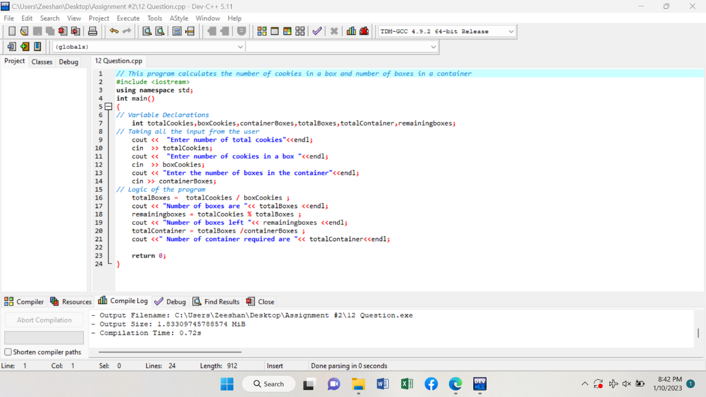

**Program # 12 (Output)**

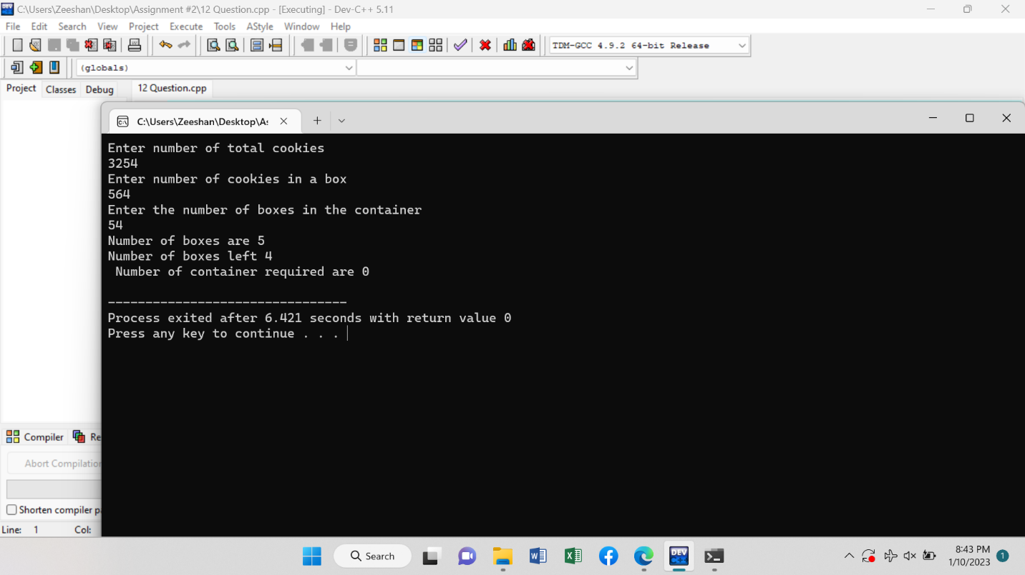

**Program # 13 (Code)**

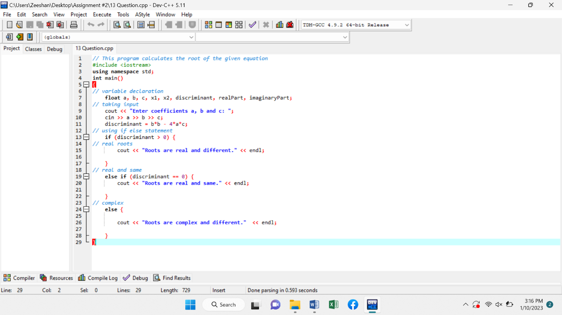

**Program # 13 (Output)**

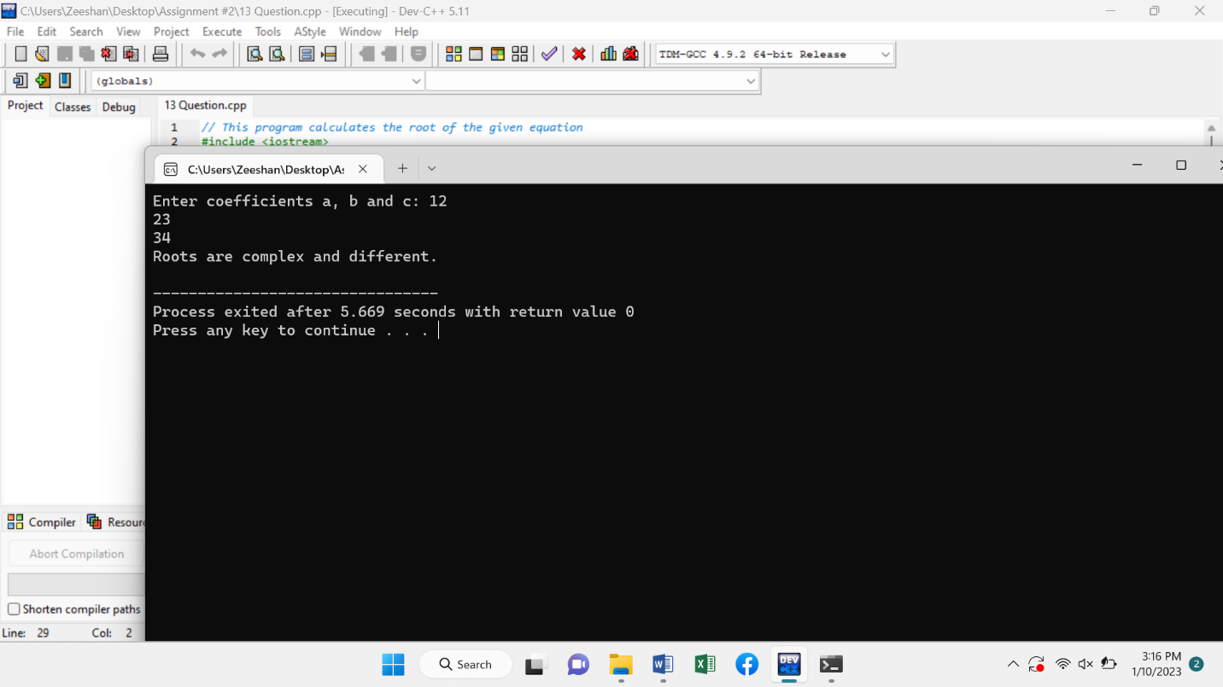

**Program # 14 (Code)**

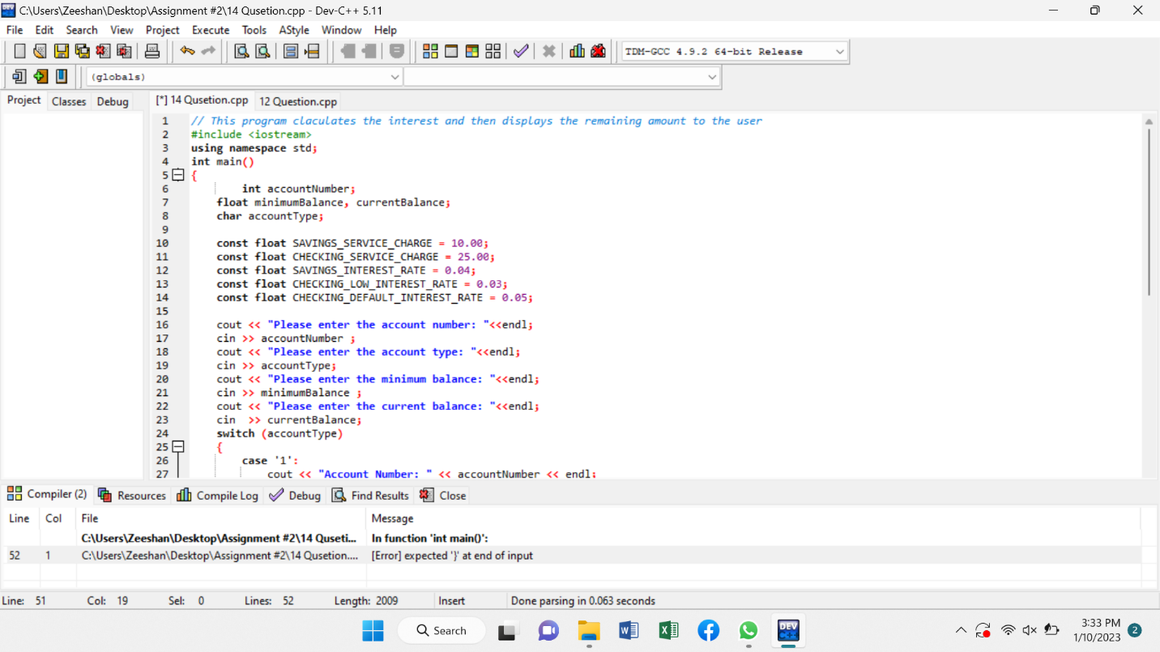

**Another ………….**

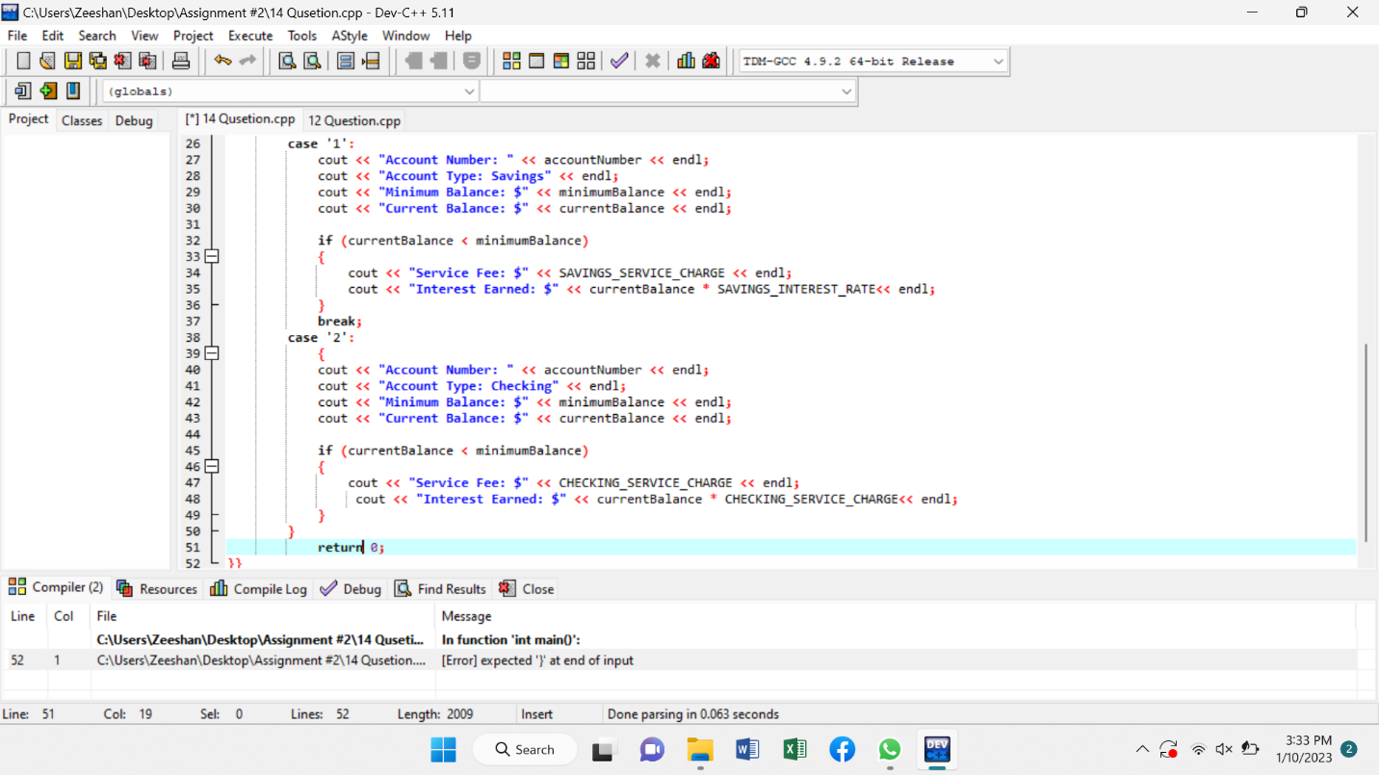

**Program # 14 (Output)**

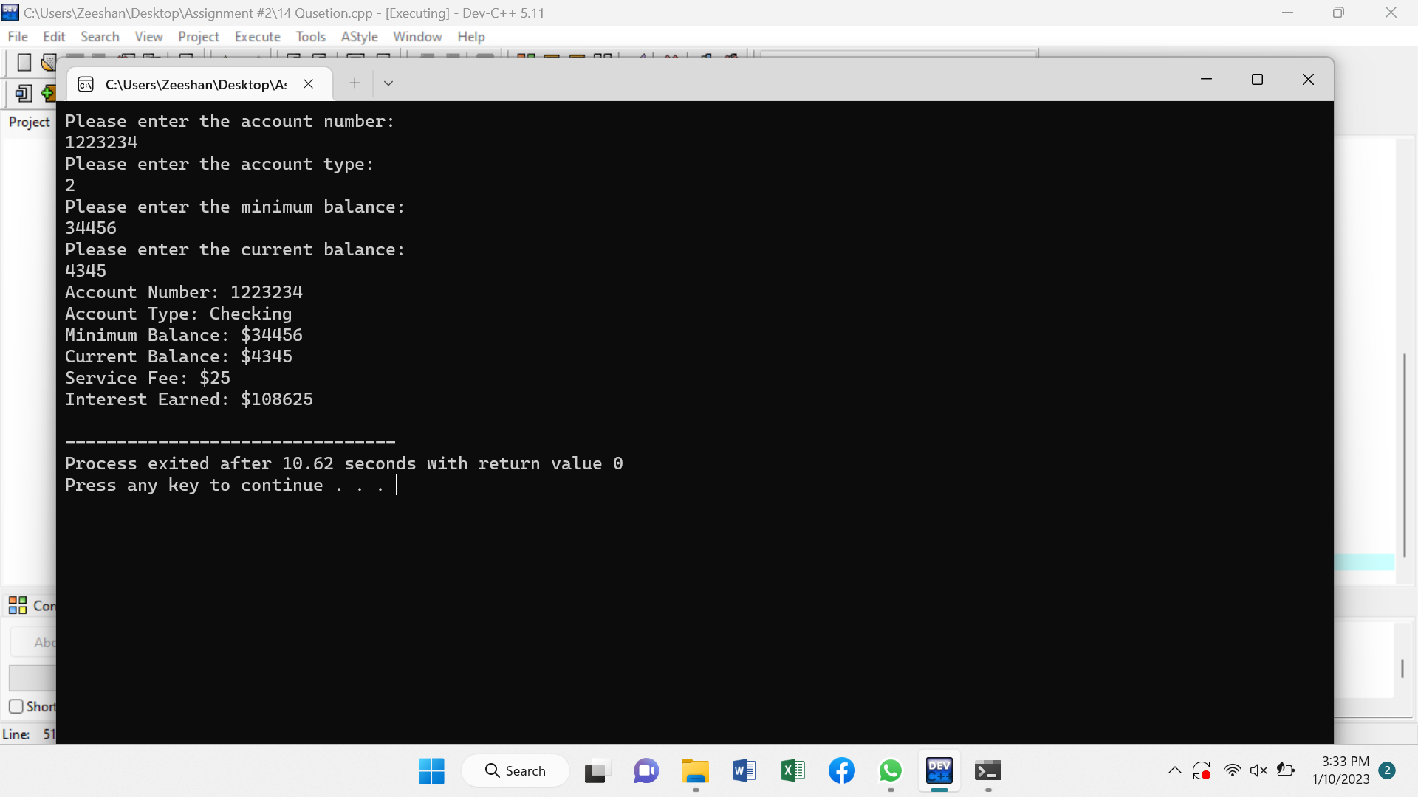

**Program # 15 (Code)**

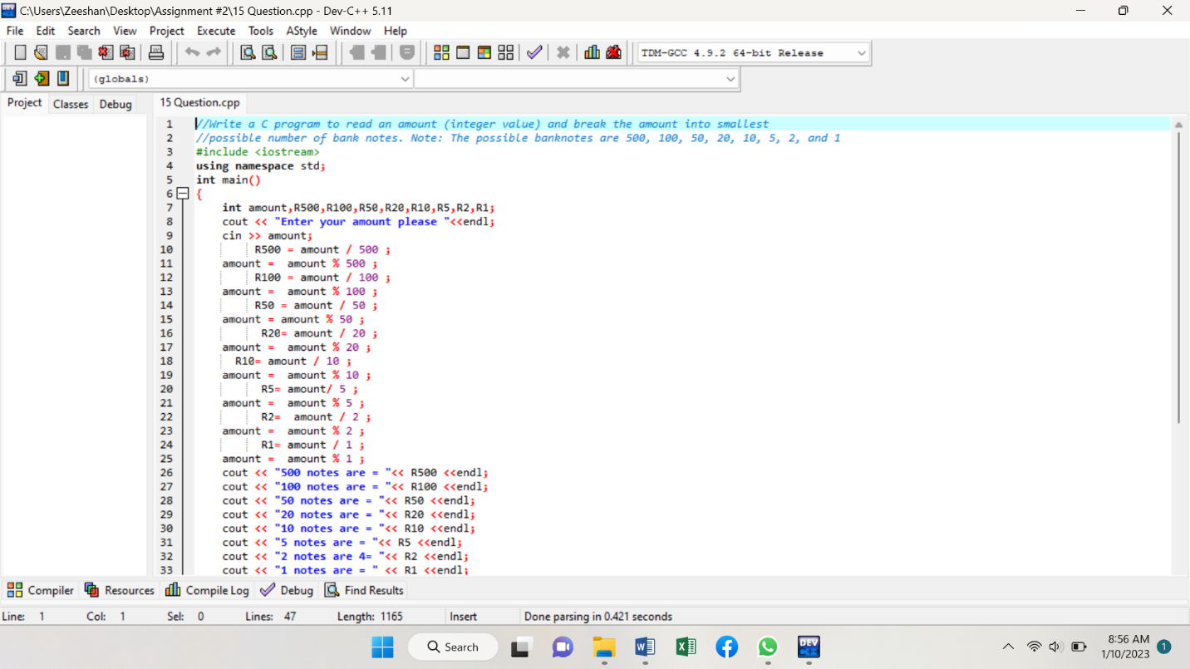

**Another ………….**

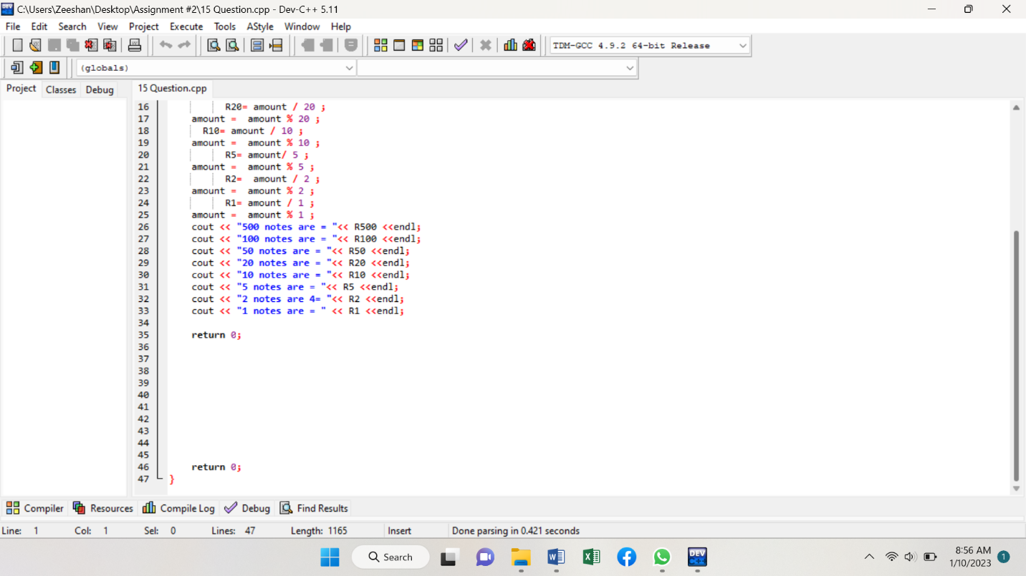

**Program # 15 (Output)**

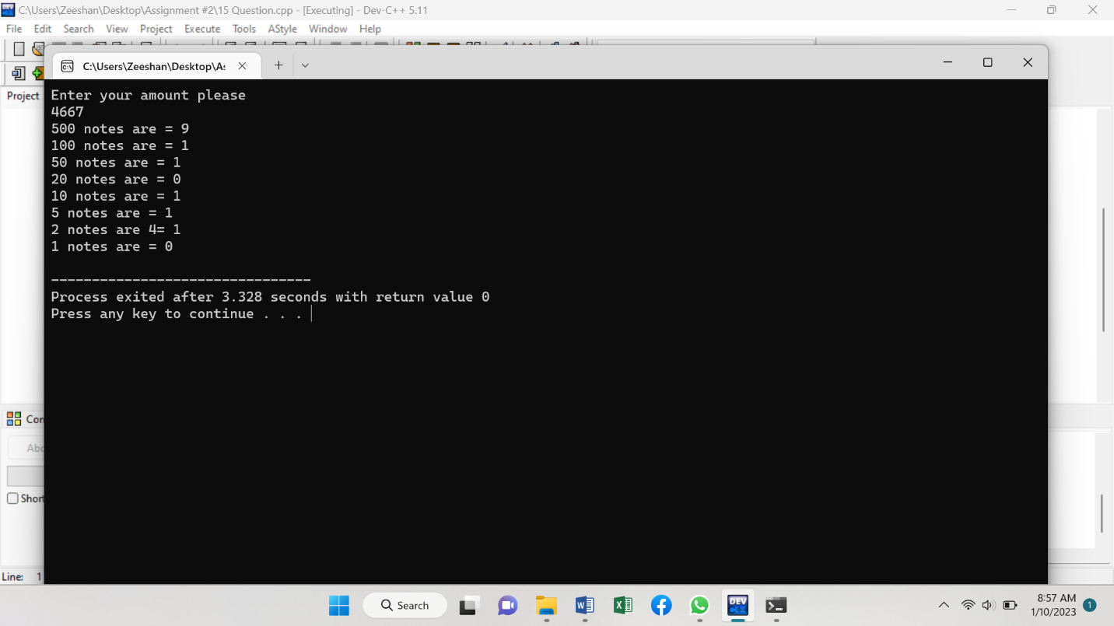

**Program # 16 (Code)**

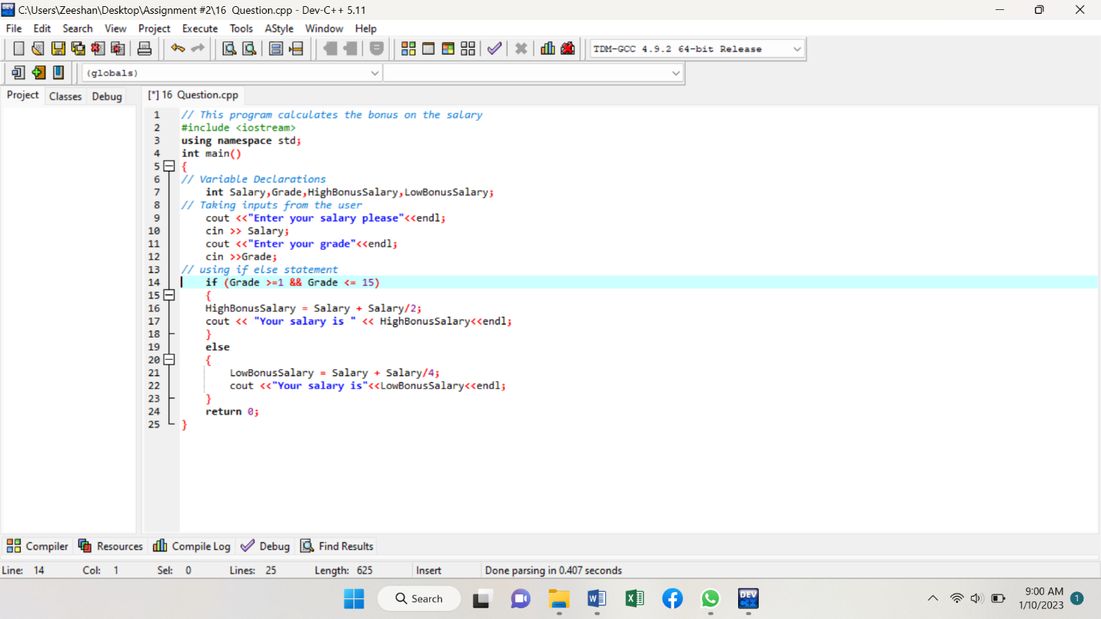

**Program # 16 (Output)**

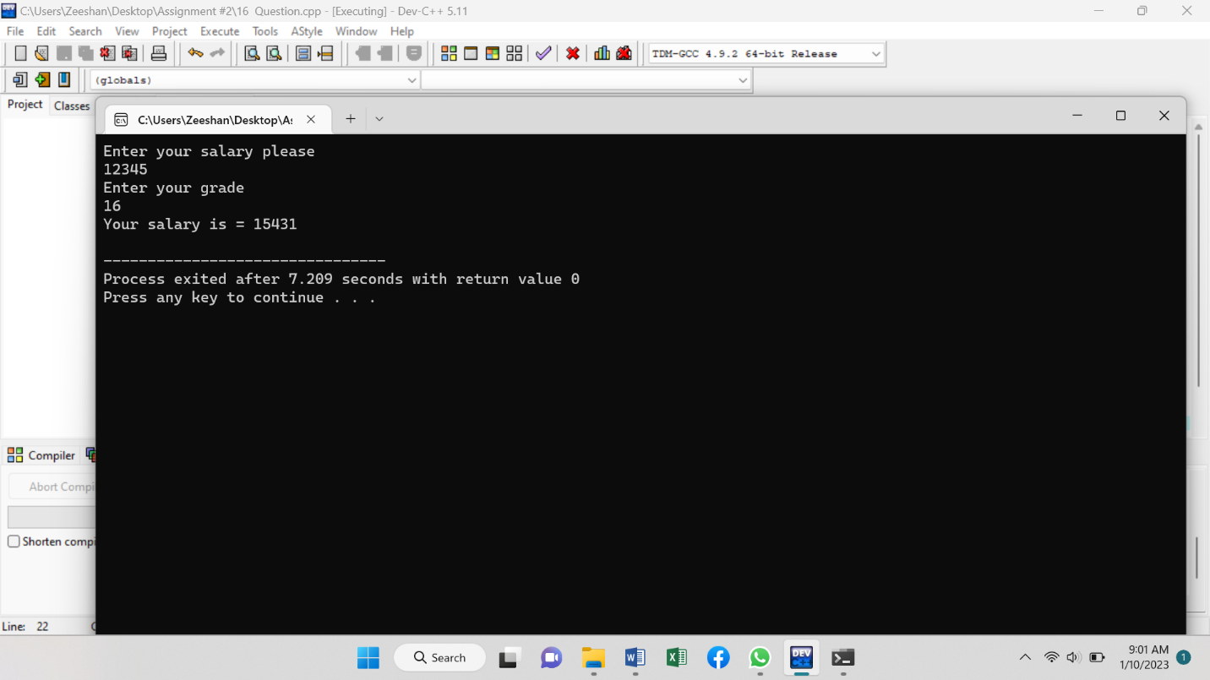

**Program # 18 (Code)**

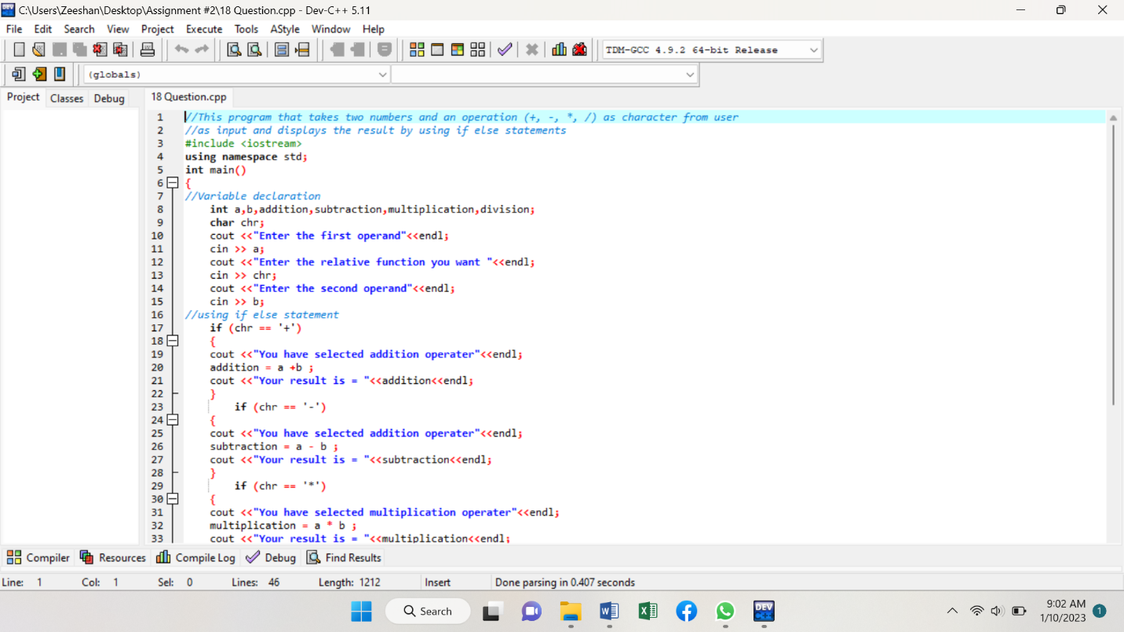

**Another …………..**

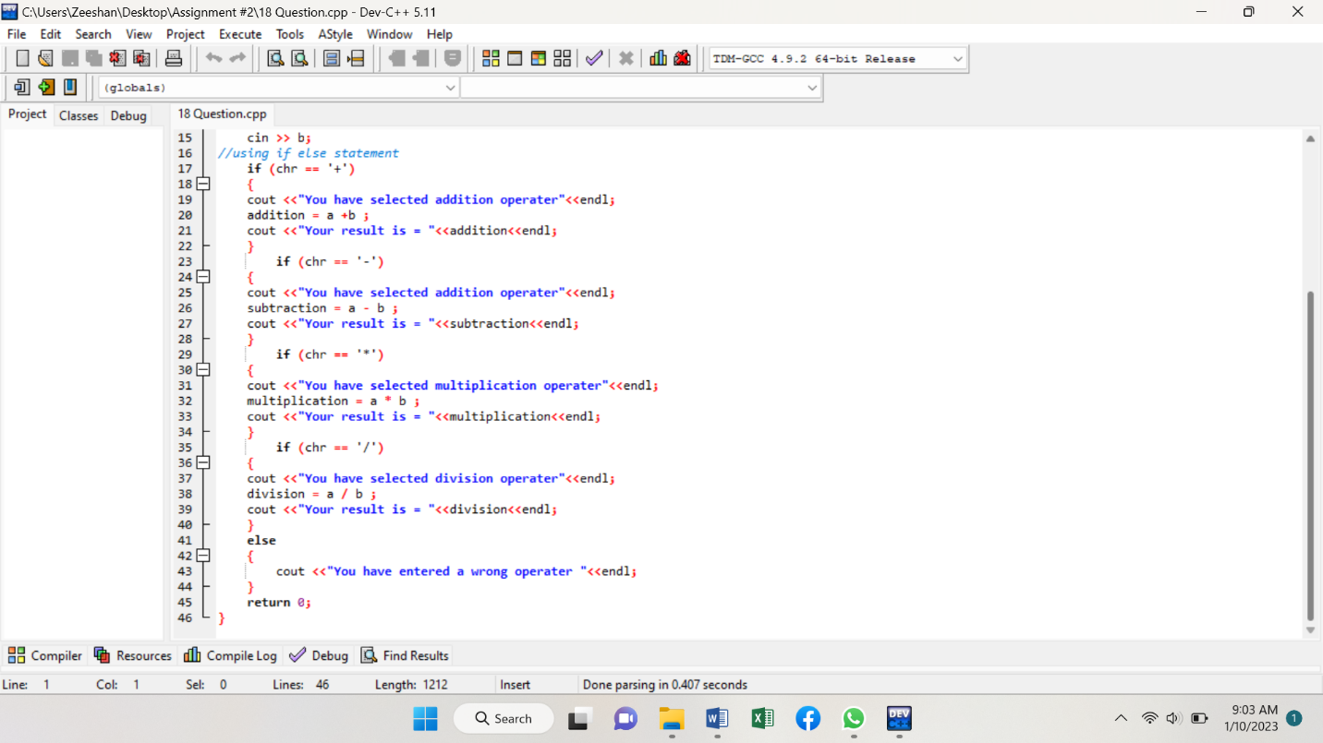

**Program # 18 (Output)**

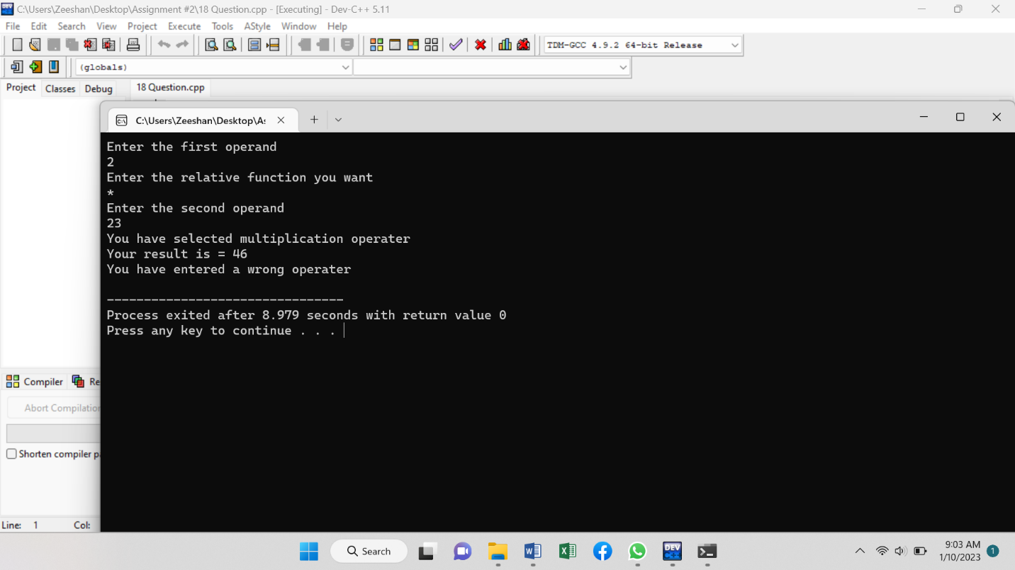

**Program # 19 (Code)**

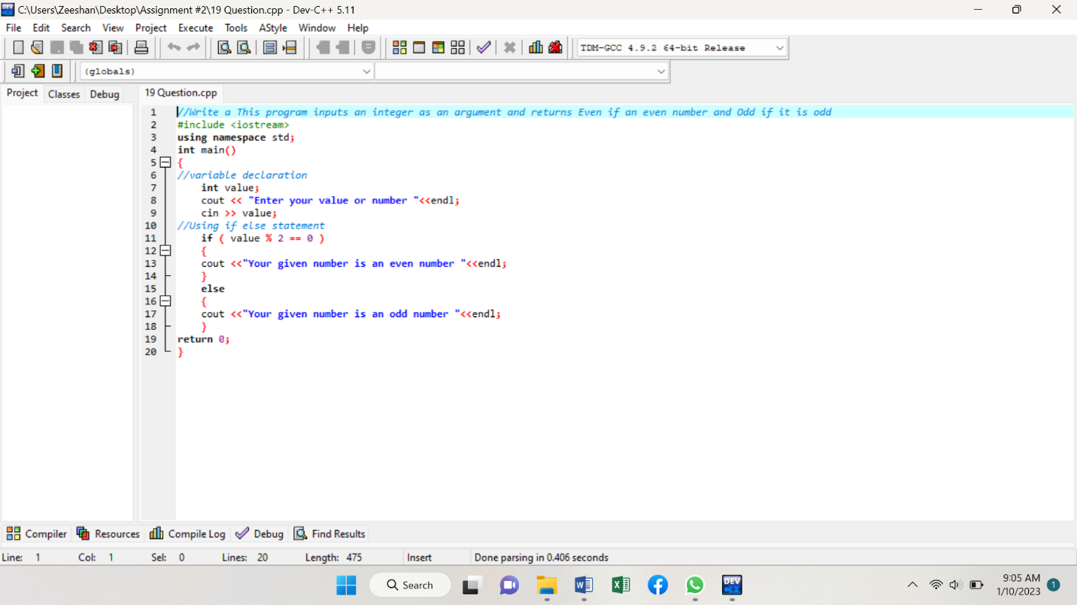

**Program # 19 (Output)**

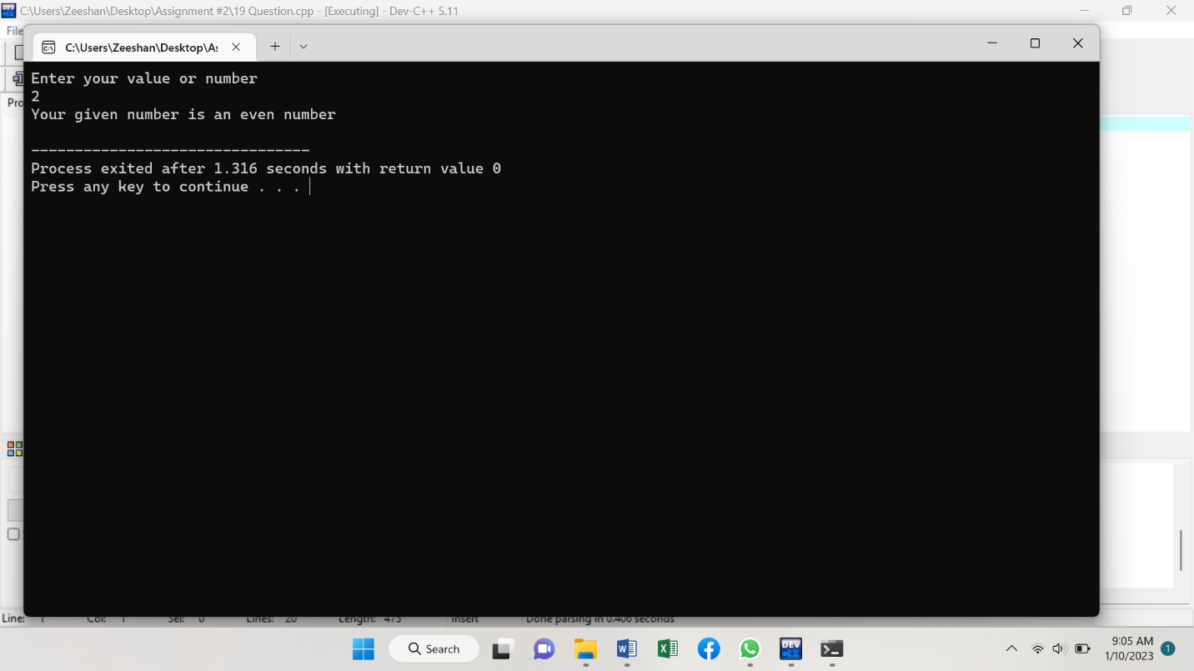

**Program # 20 (Code)**

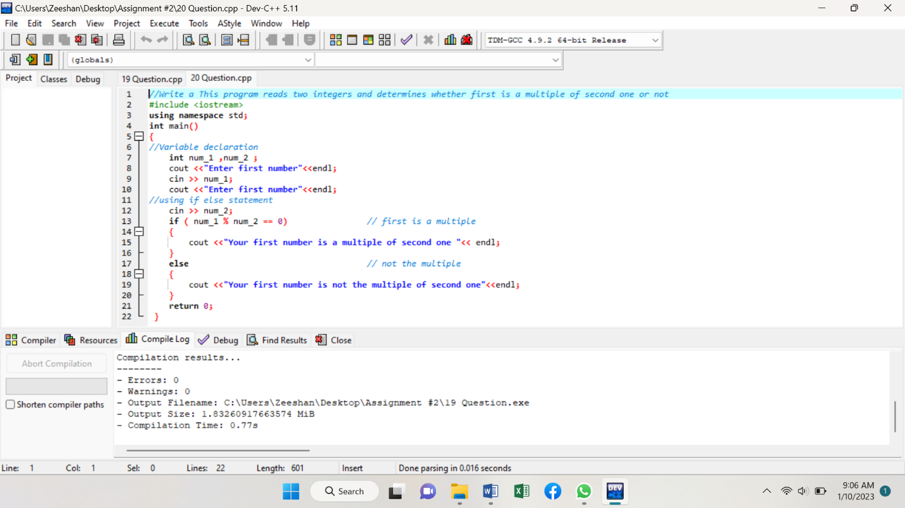

**Program # 20 (Output)**

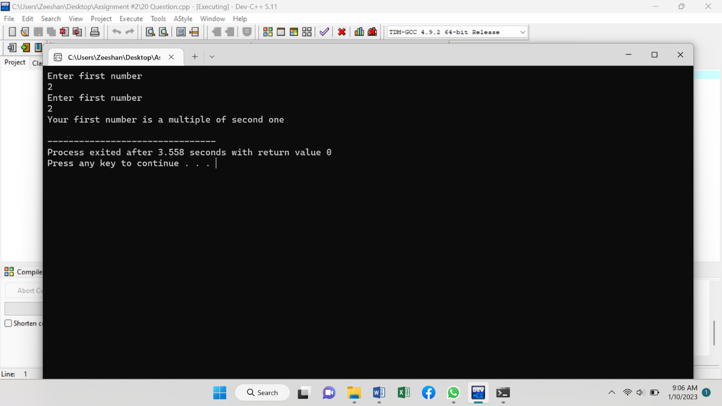

**Program # 21 (Code)**

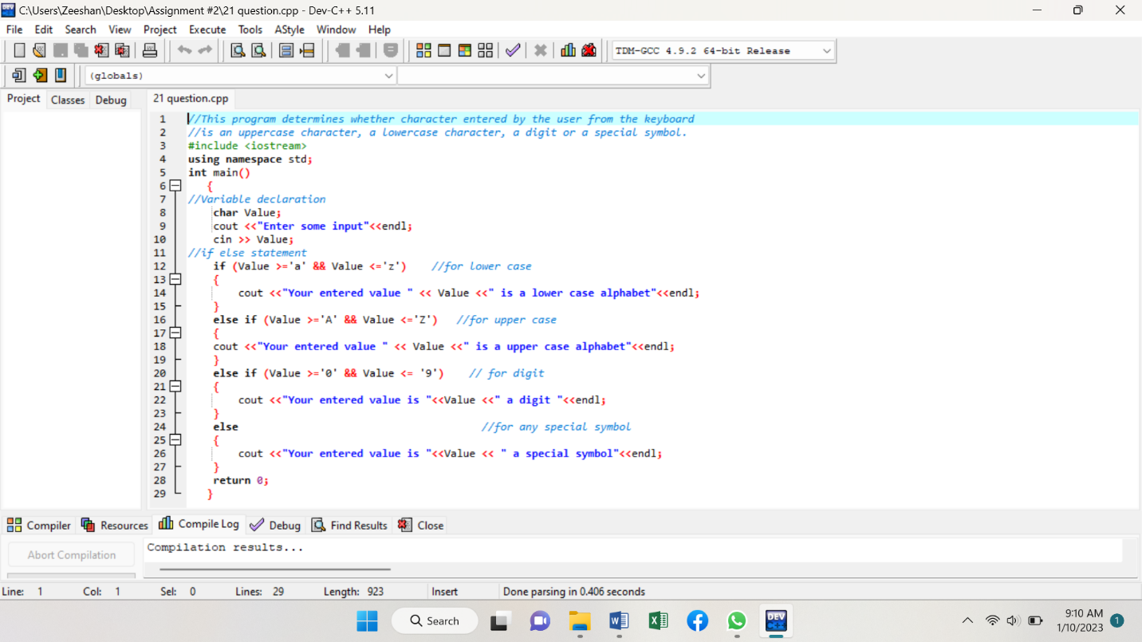

**Program # 21 (Output)**

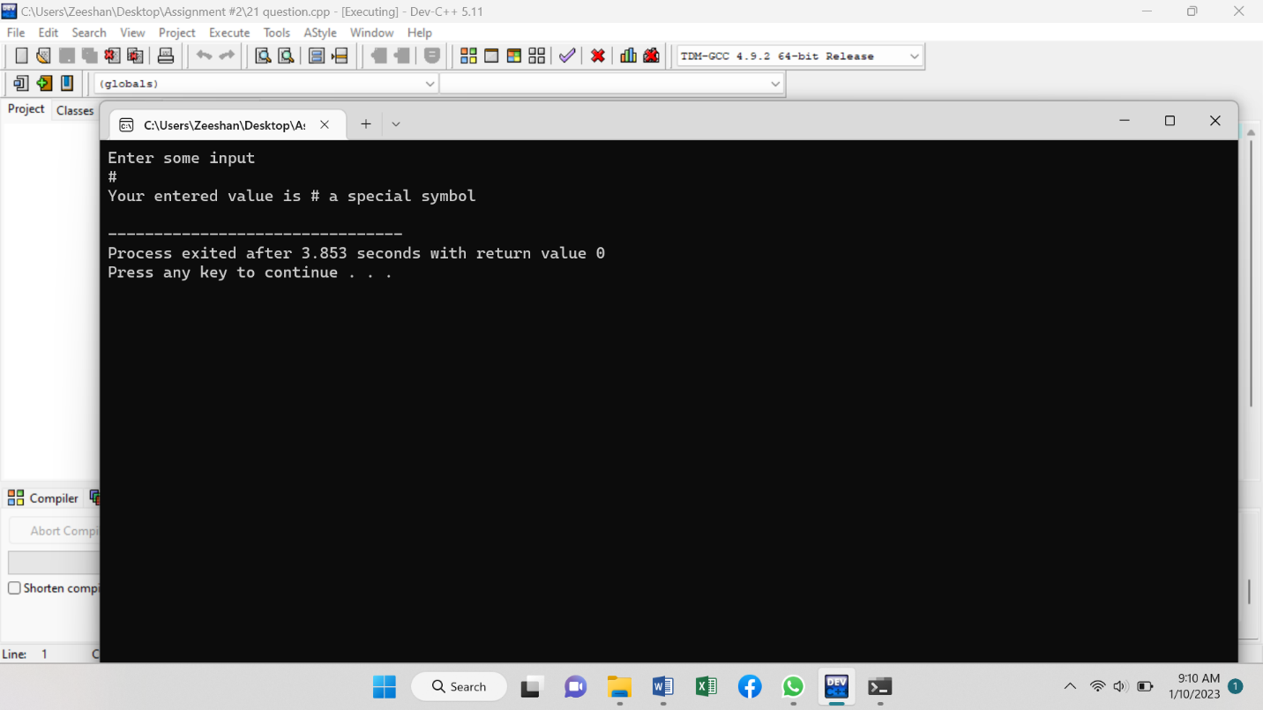

**Program 24 (Code)**

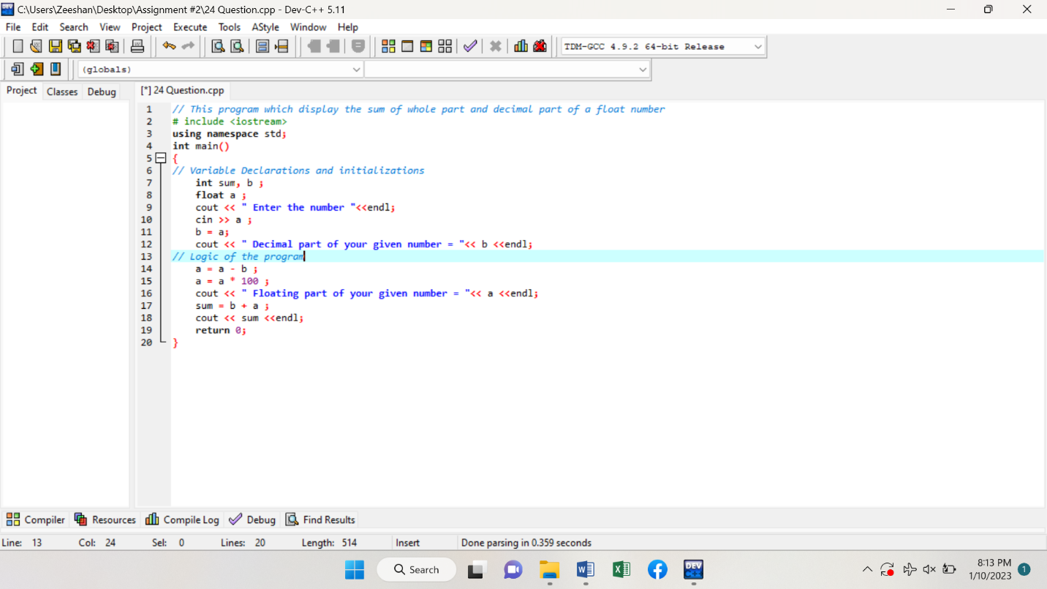

**Program # 24 (Output)**

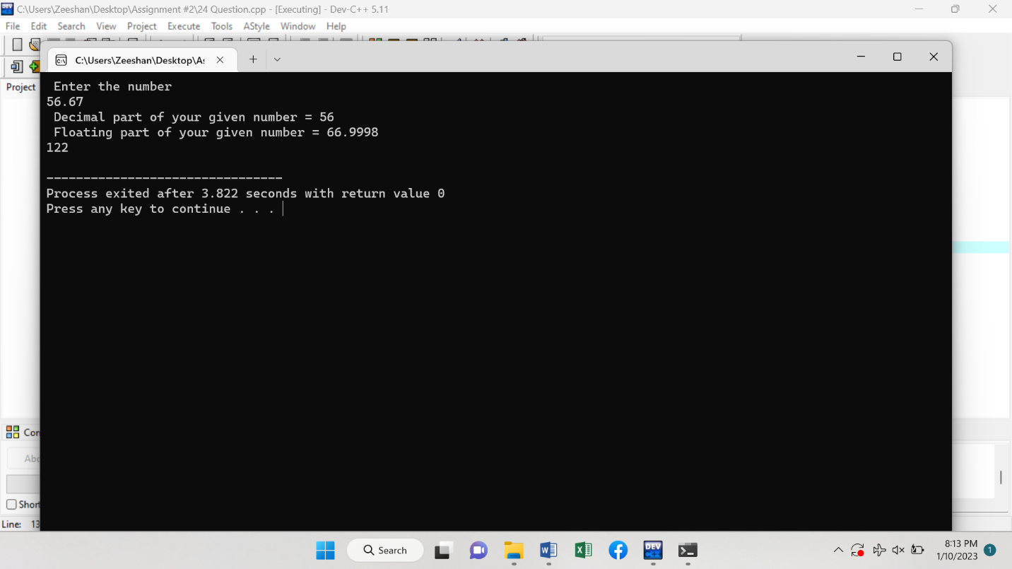

**Program # 25 (Code)**

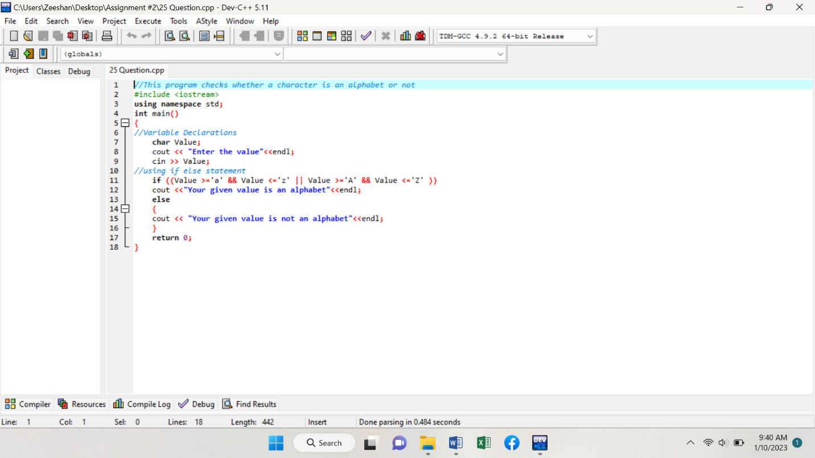

**Program # 25 (Output)**

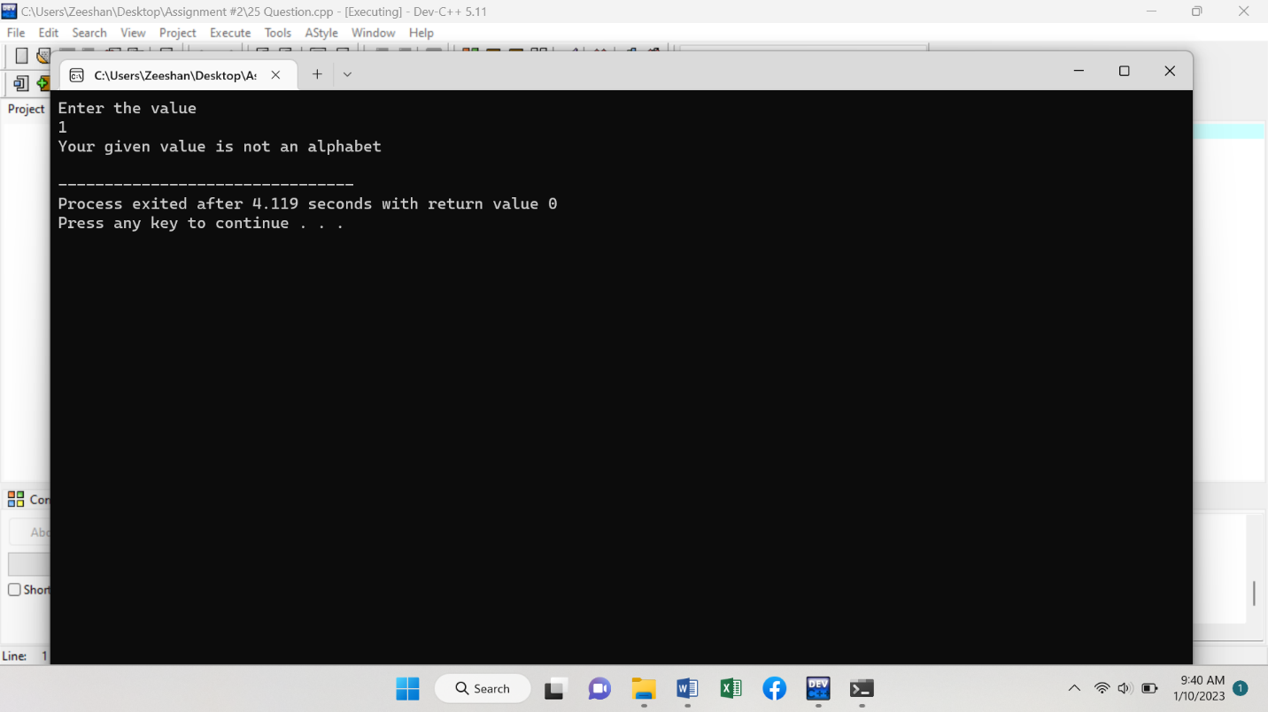

**Program # 26 (Code)**

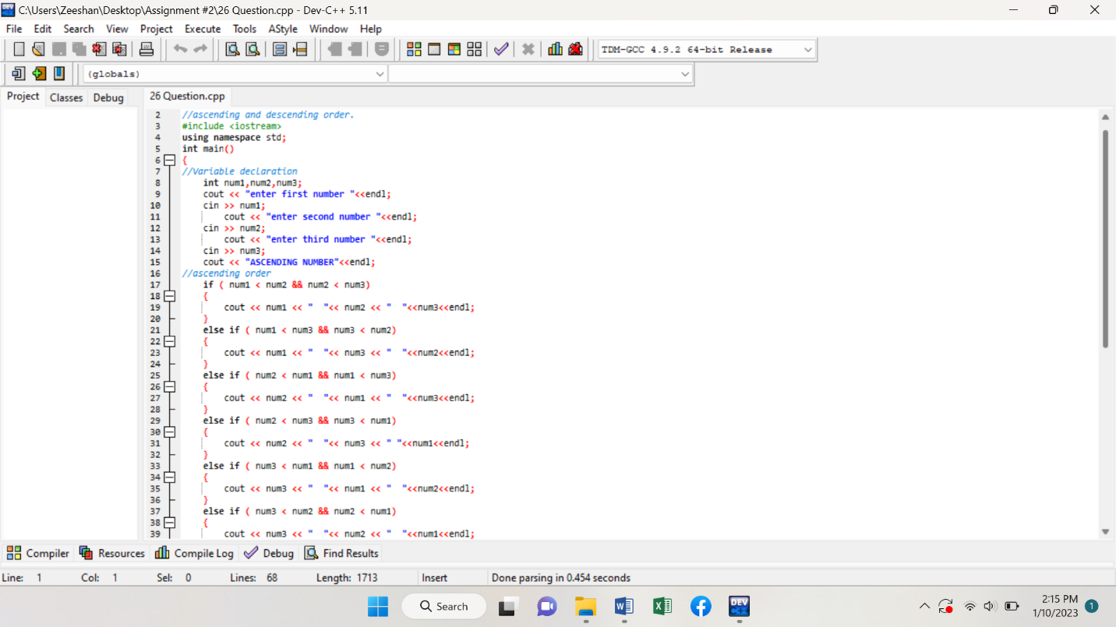

**Another …………….**

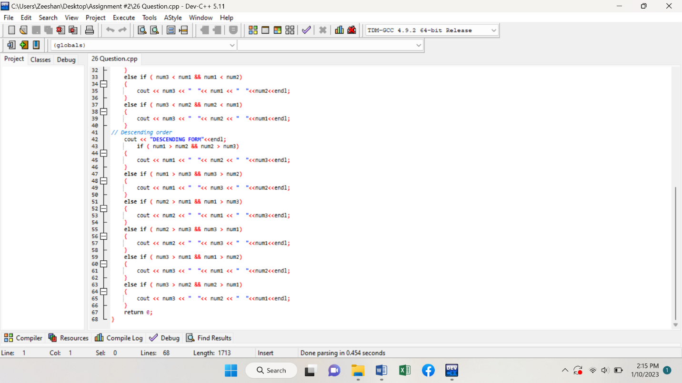

**Program # 26 (Output)**

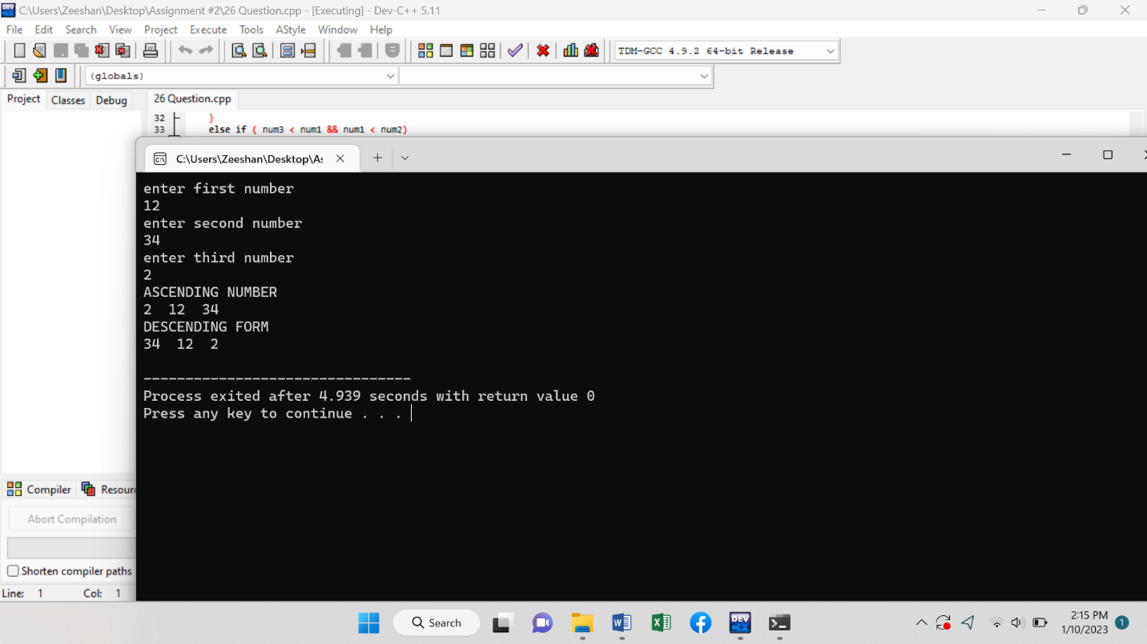

**Program # 27 (Code)**

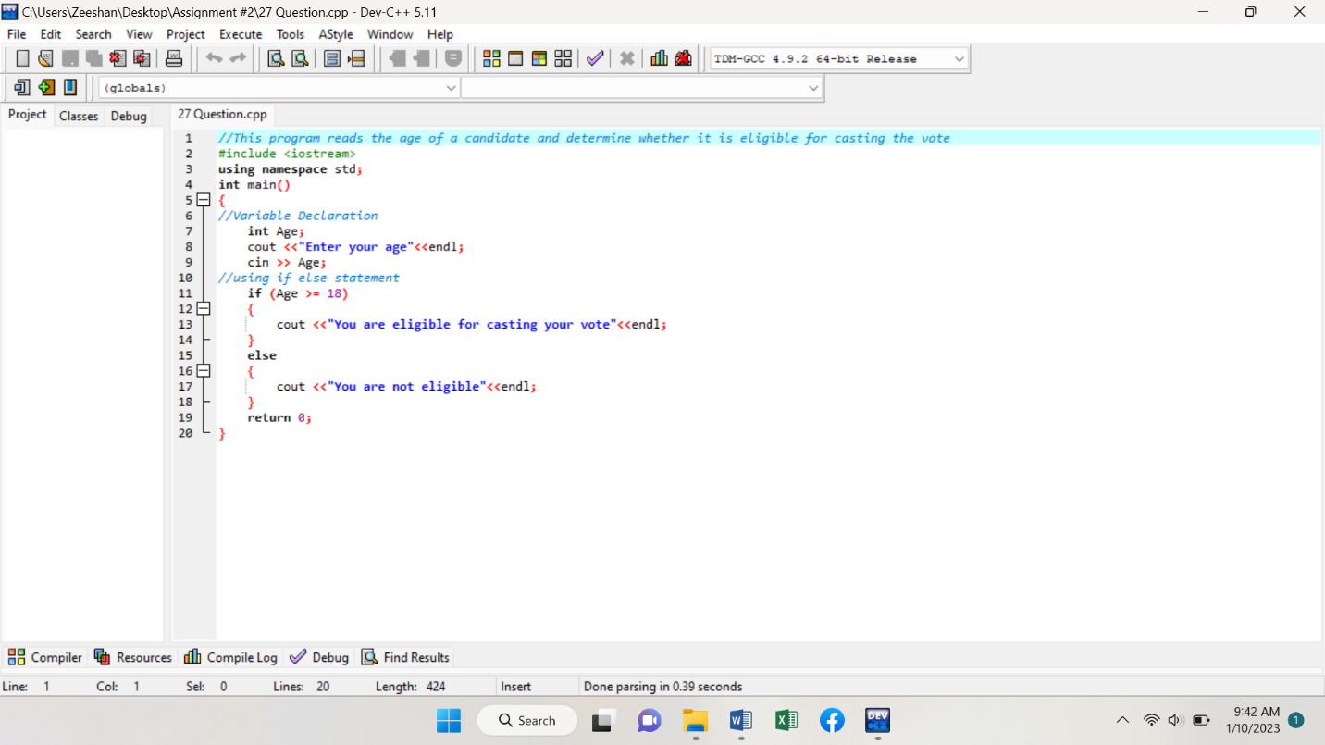

**Program # 27 (Output)**

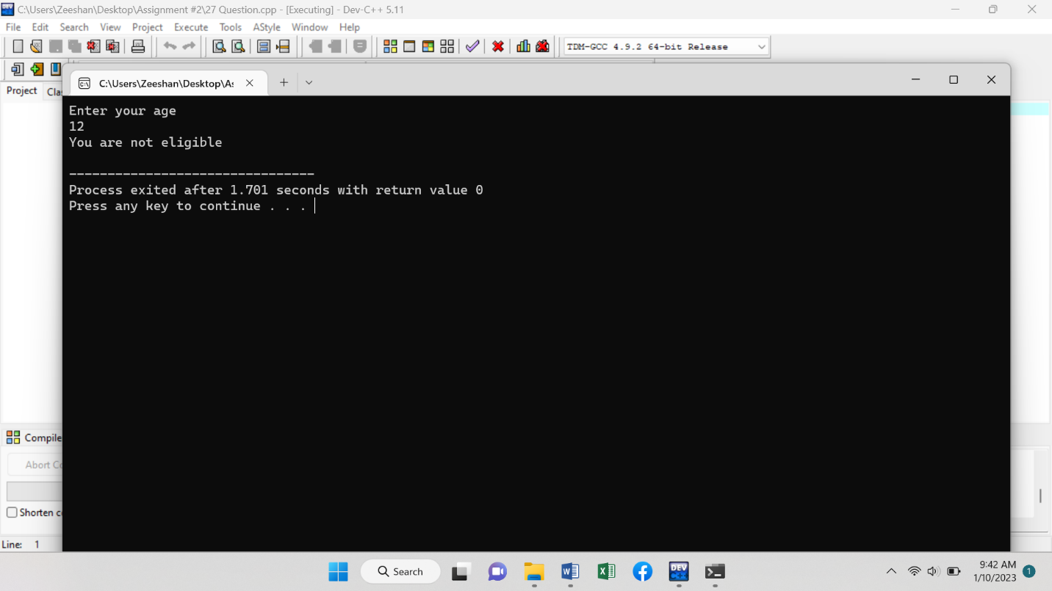

**Program # 28 (Code)**

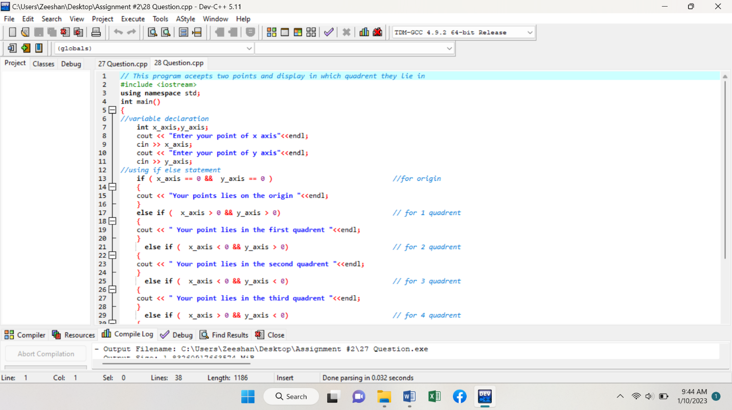

**Another ……….**

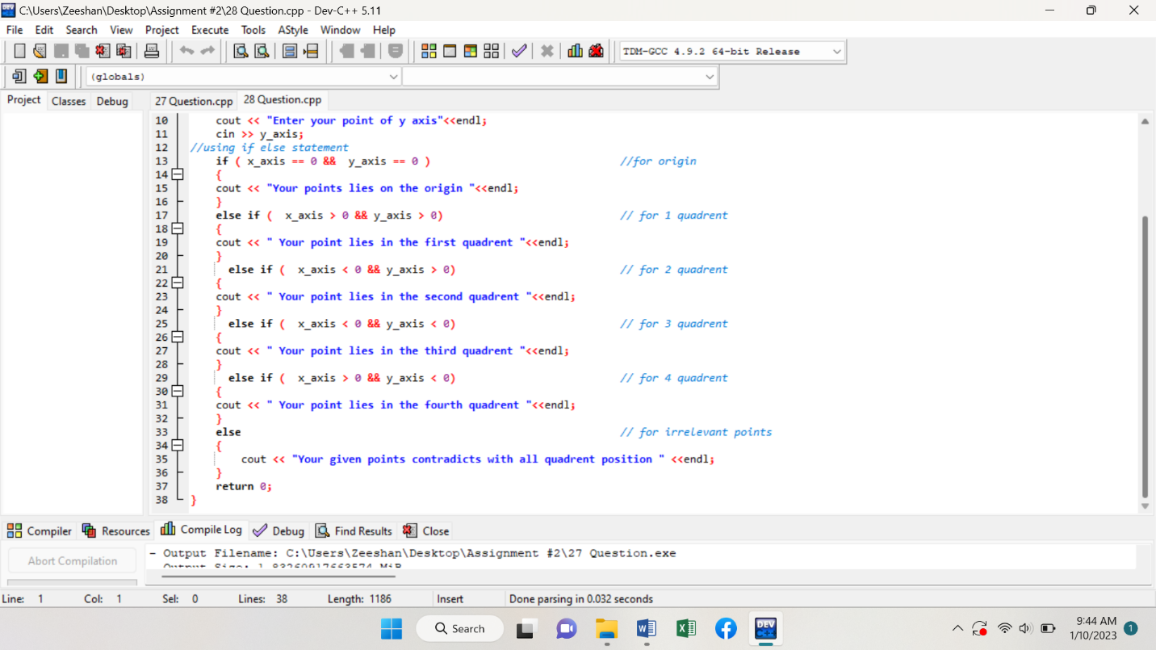

**Program # 28 (Output)**

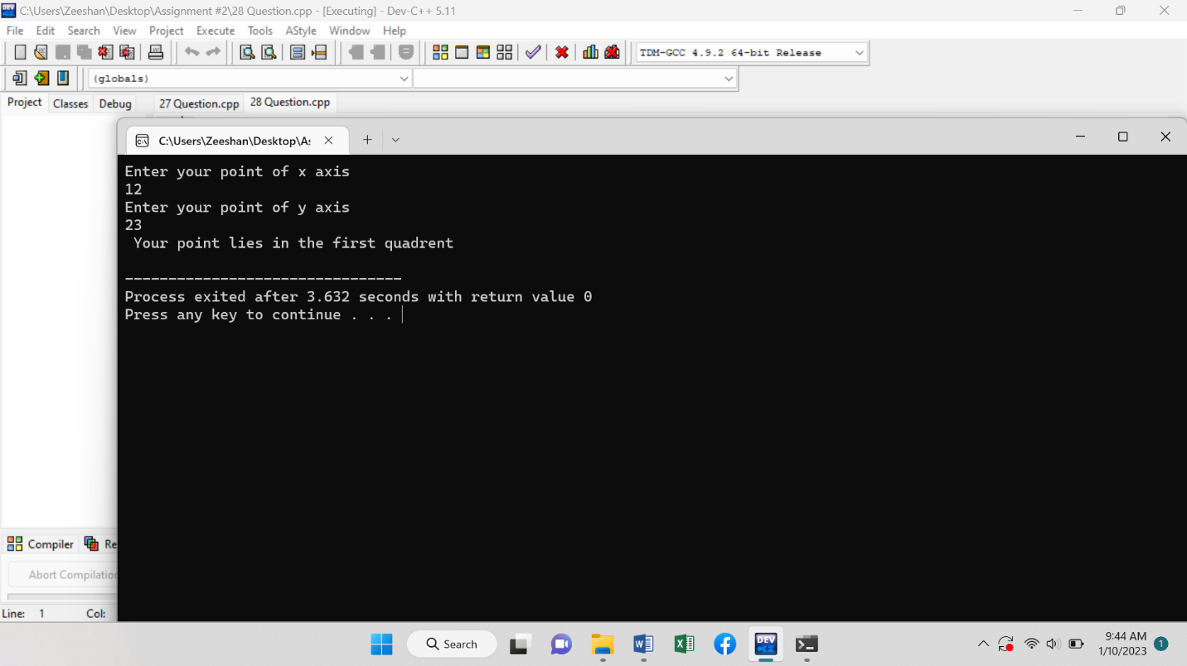

**Program # 29 (Code)**

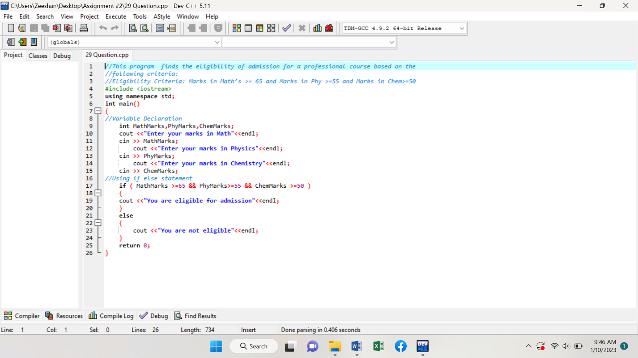

**Program # 29 (Output)**

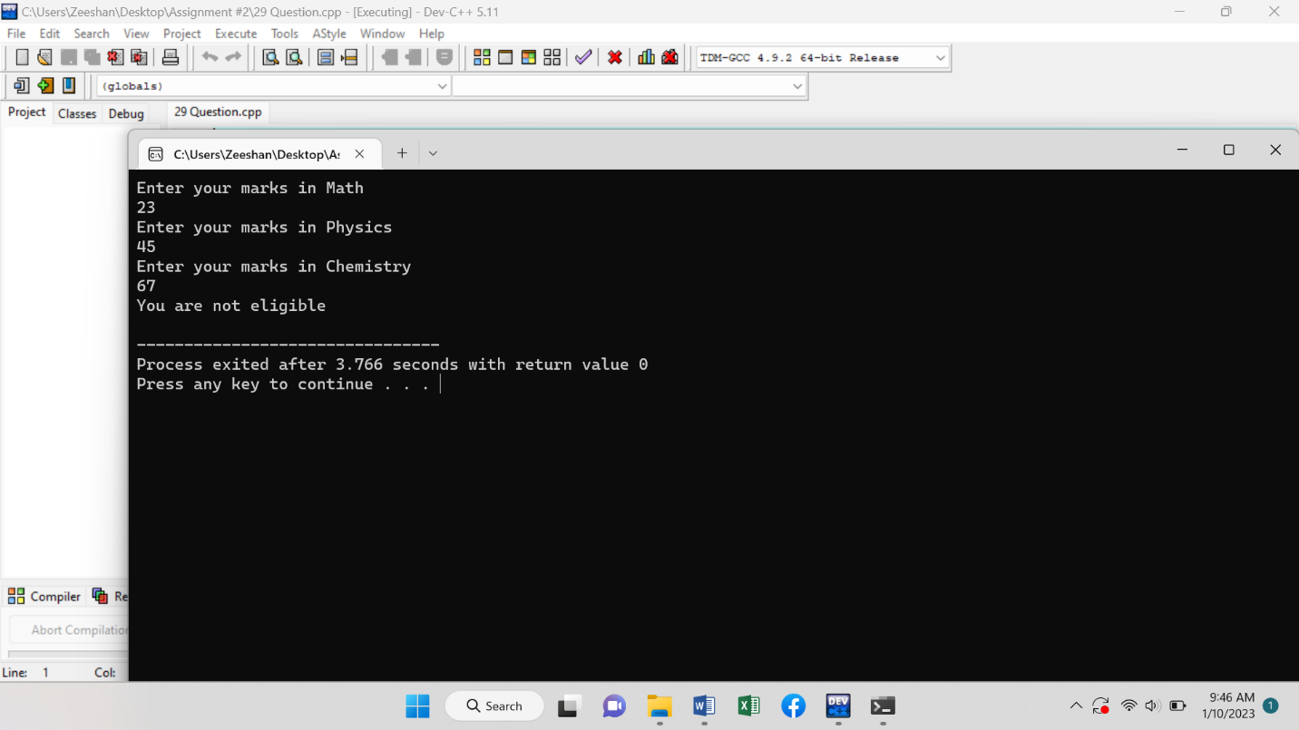

**Program # 30 (Code)**

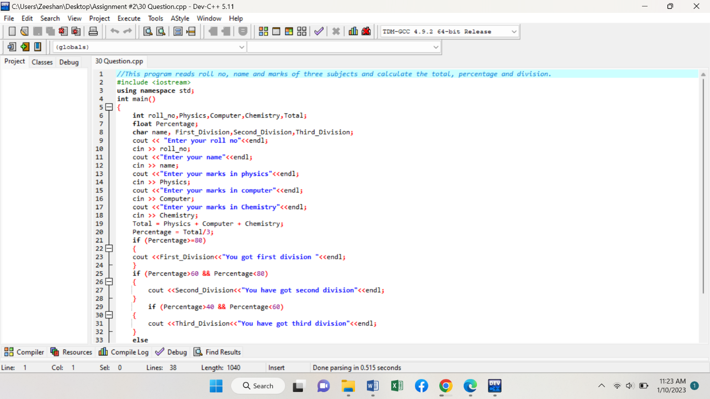

**Another ………..**

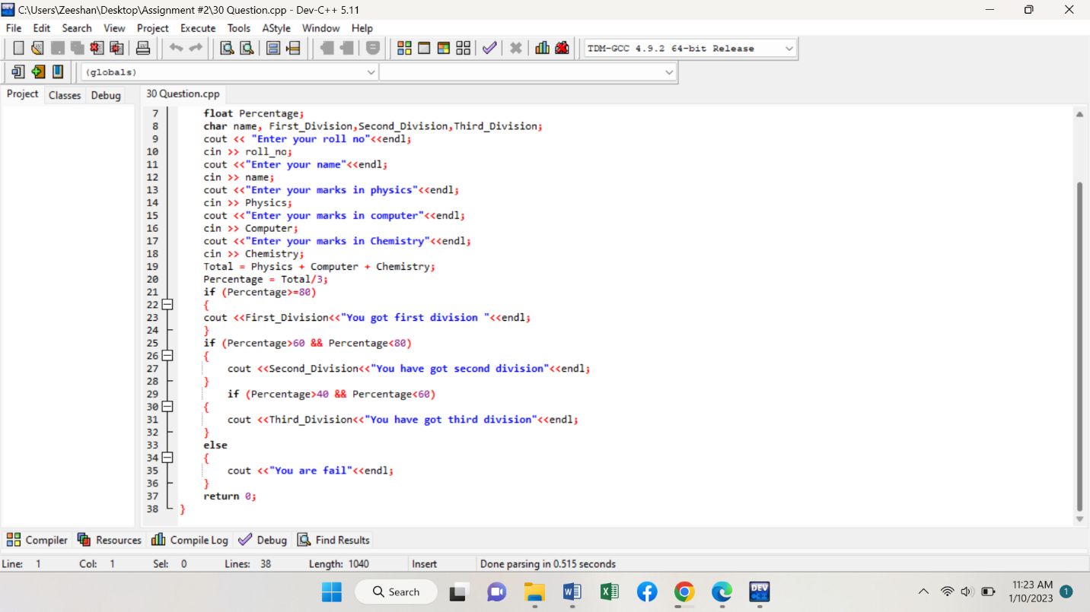

**Program # 30 (Output)**

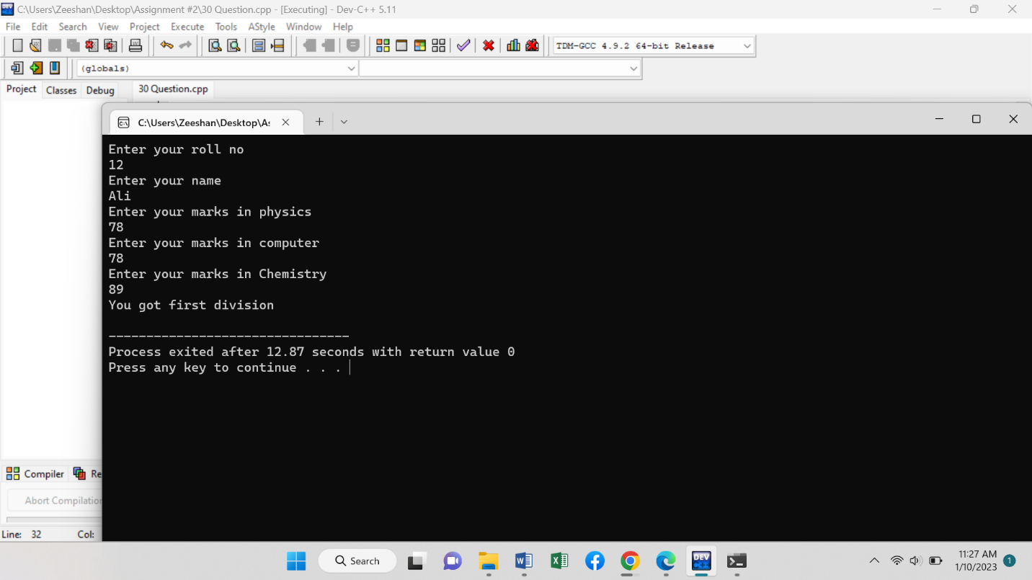

**Program # 31 (Code)**

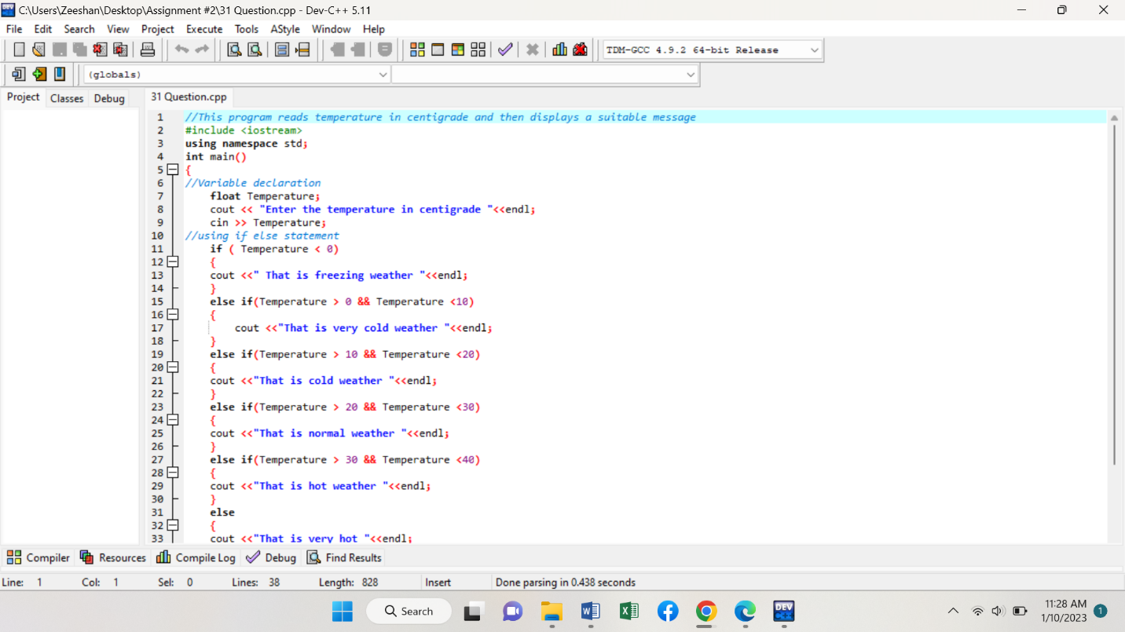

**Another ……….**

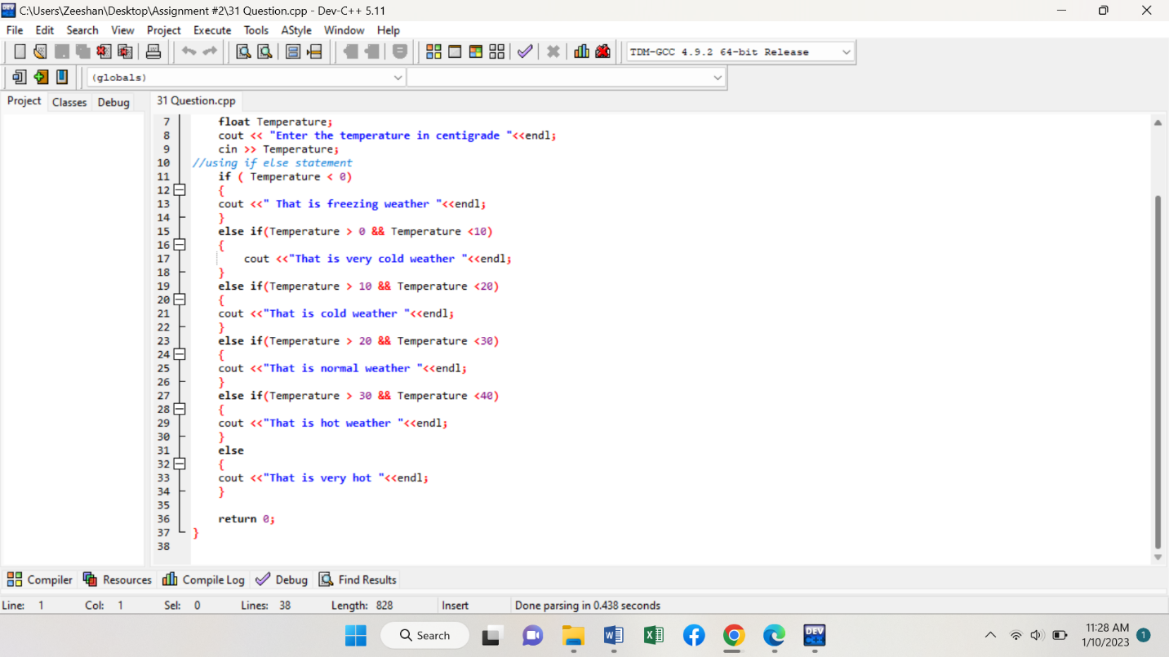

**Program # 31 (Output)**

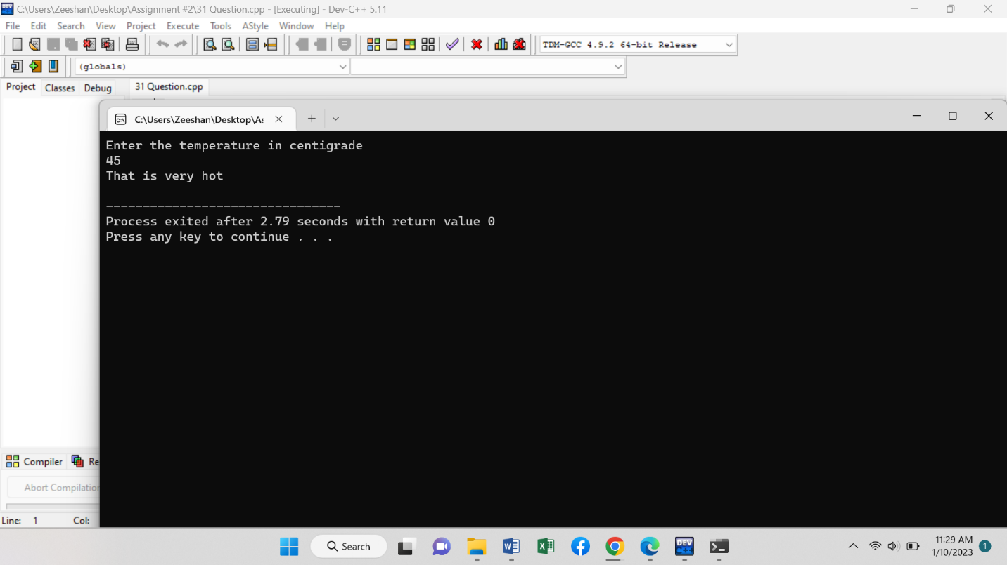

**Program # 32 (Code)**

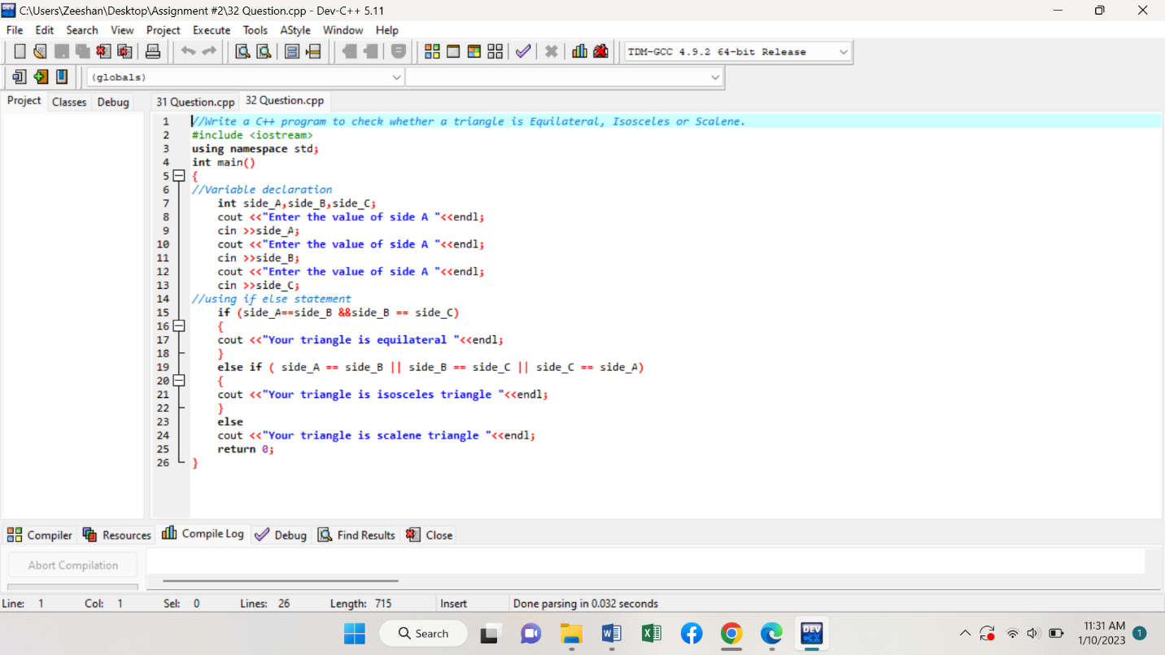

**Program # 32 (Output)**

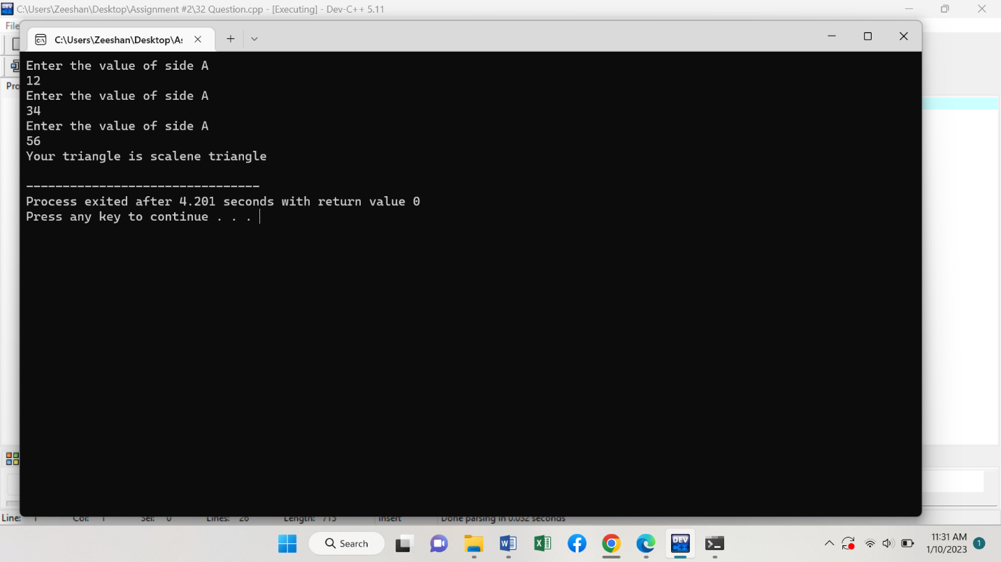

**Program # 33 (Code)**

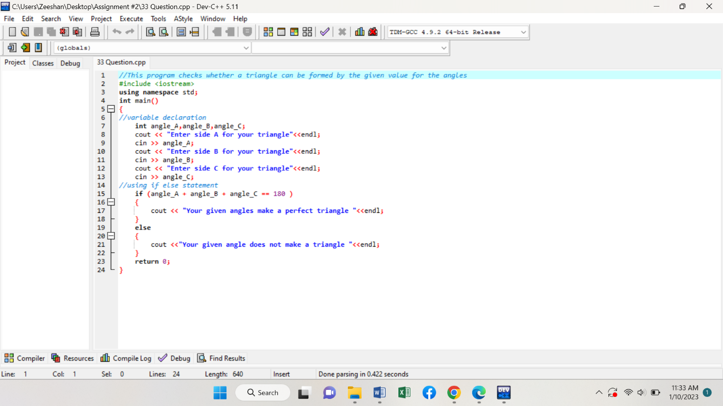

**Program # 33 (Output)**

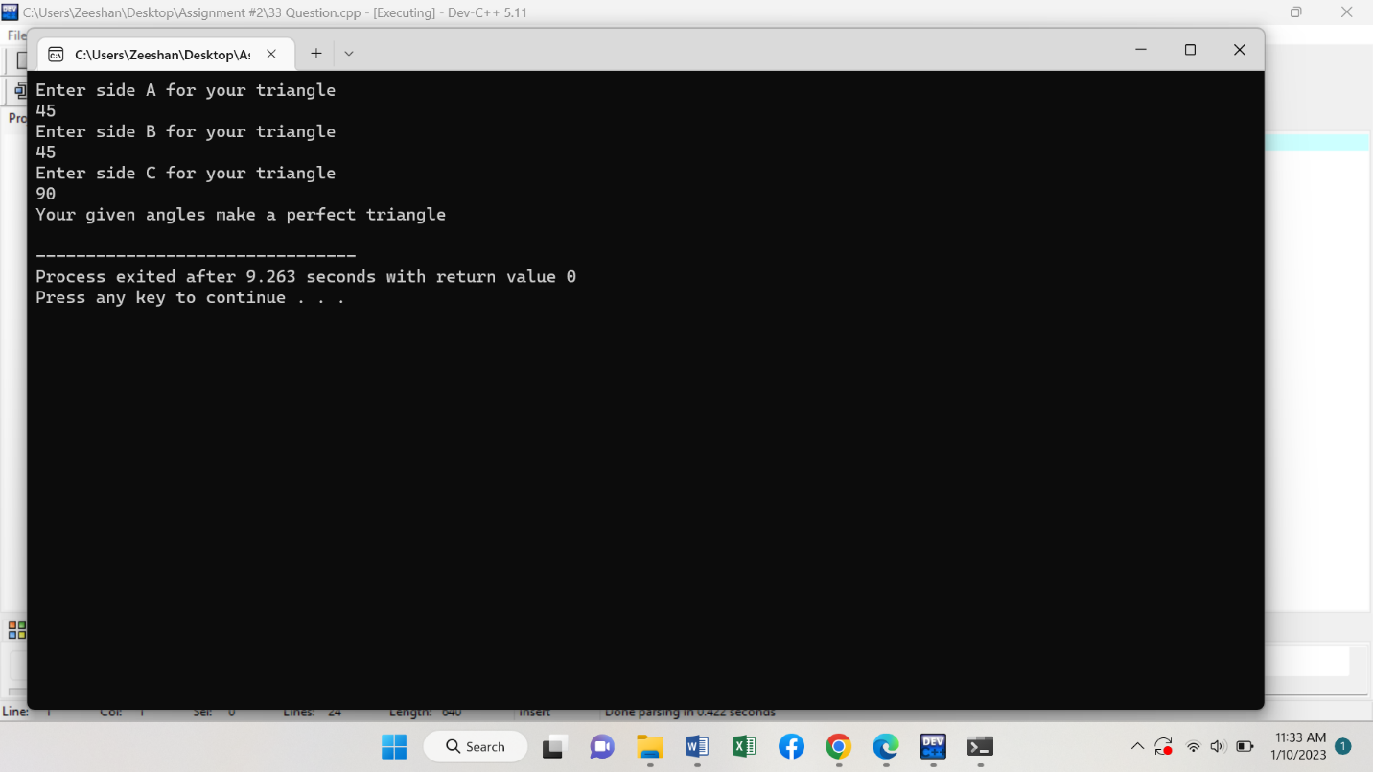

**Program # 34 (Code)**

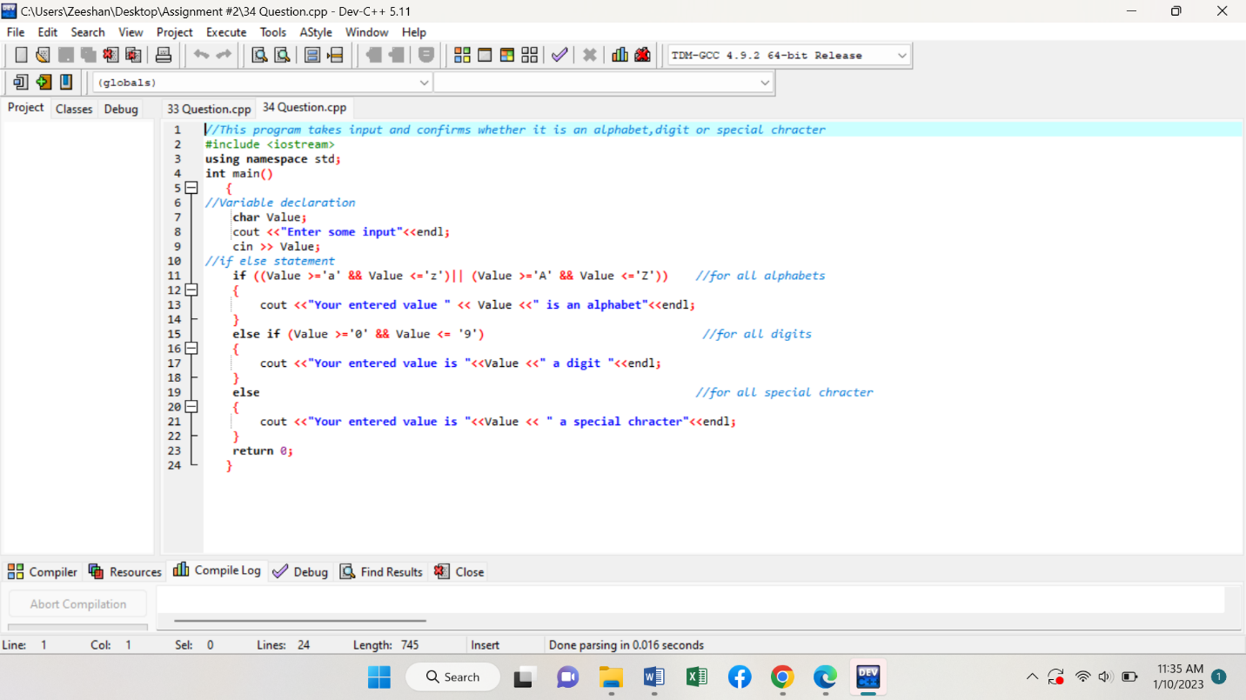

**Program # 34 (Output)**

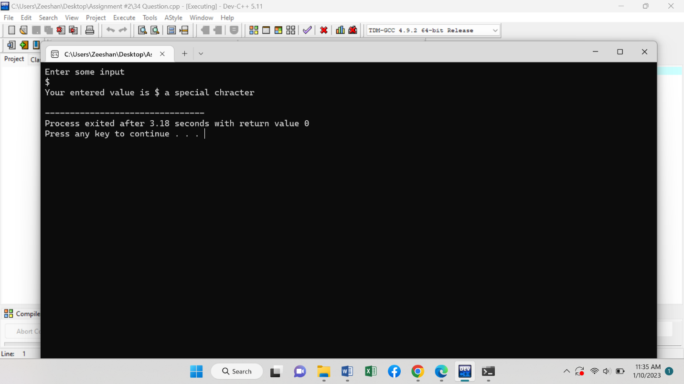

**Program # 35 (Code)**

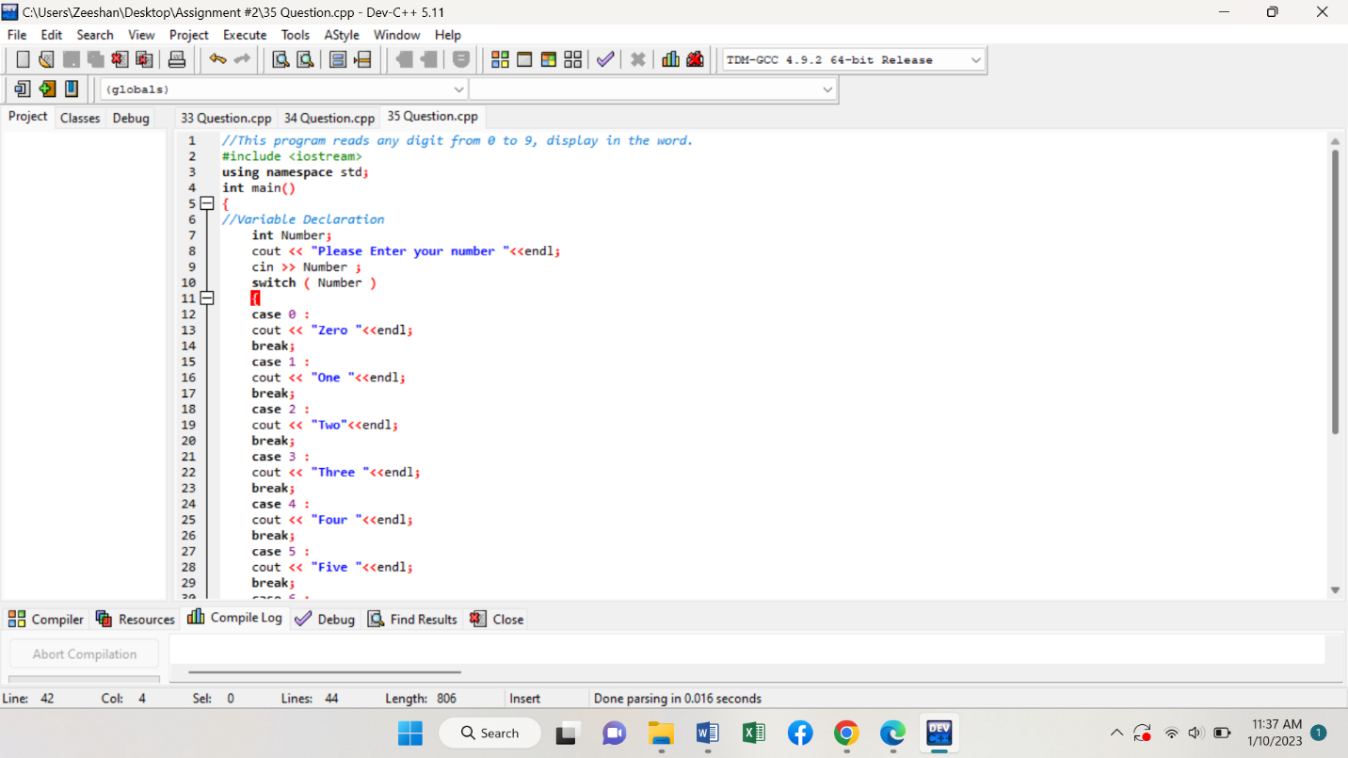

**Another ………**

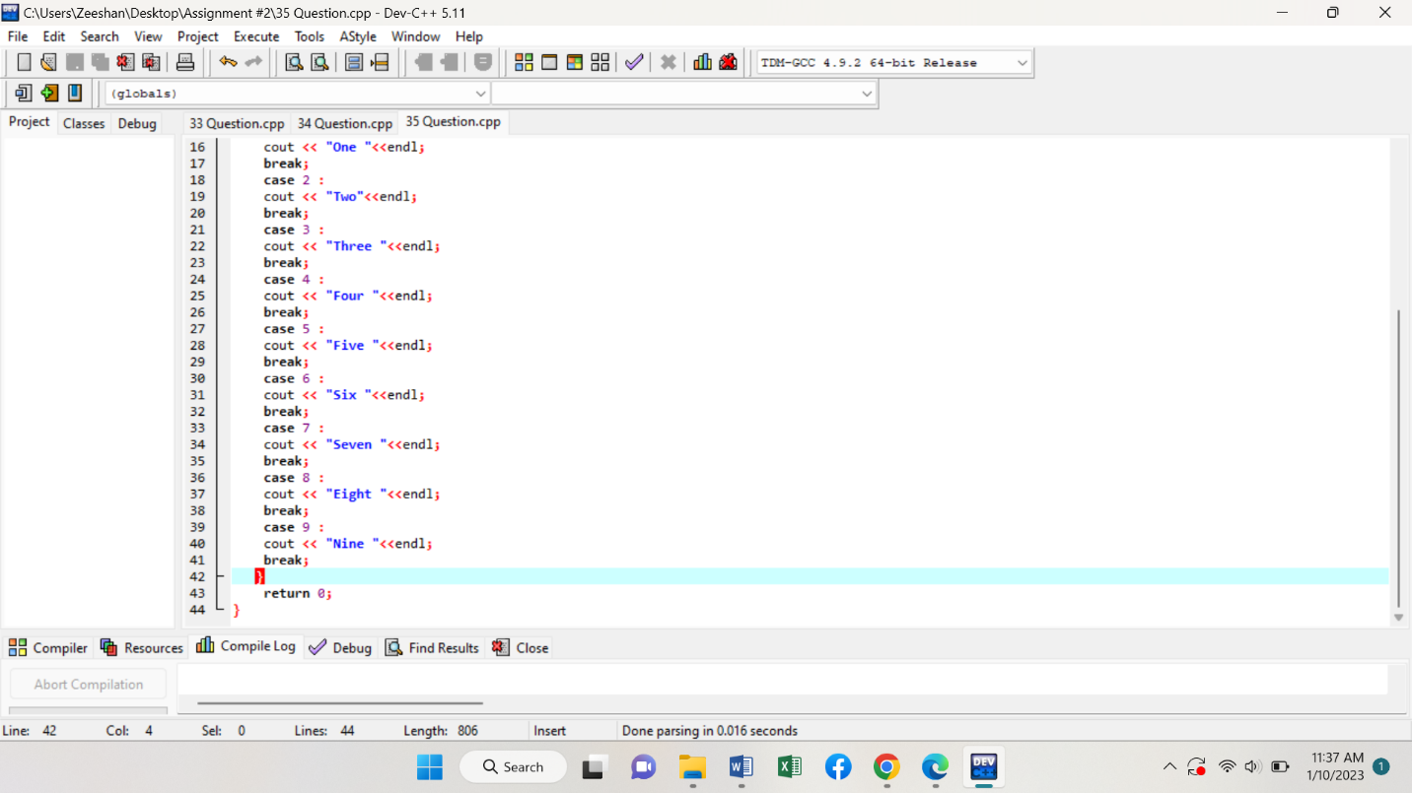

**Program # 35 (Output)**

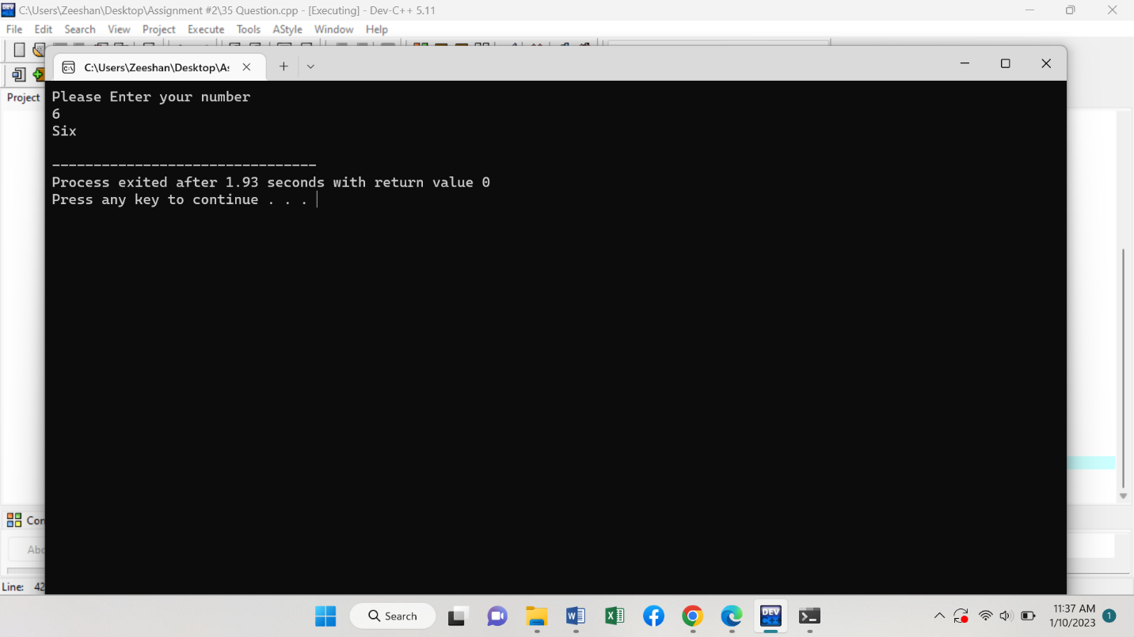

**Program # 36 (Code)**

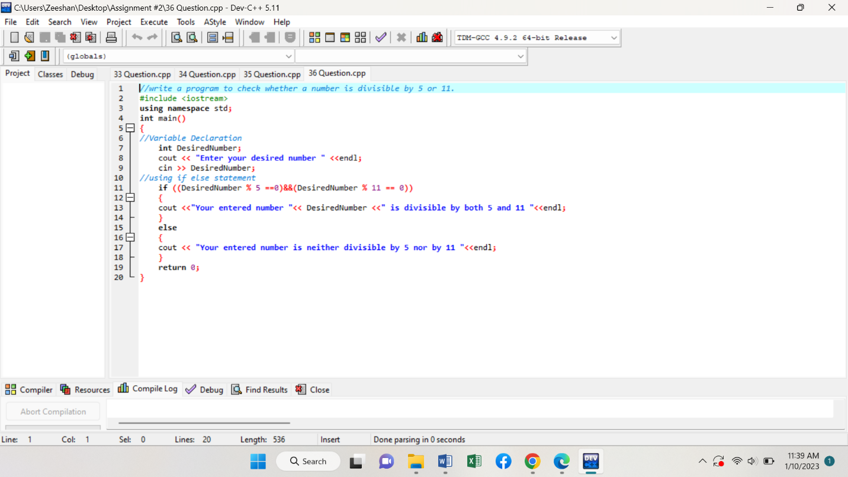

**Program # 36 (Output)**

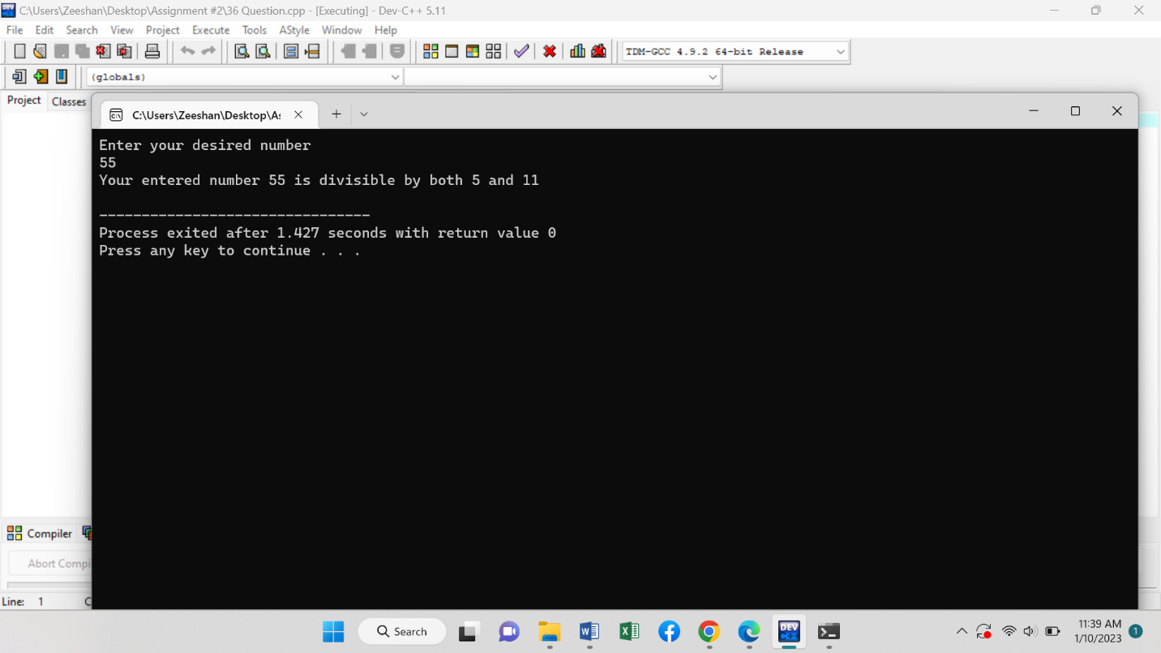

**Program # 37 (Code)**

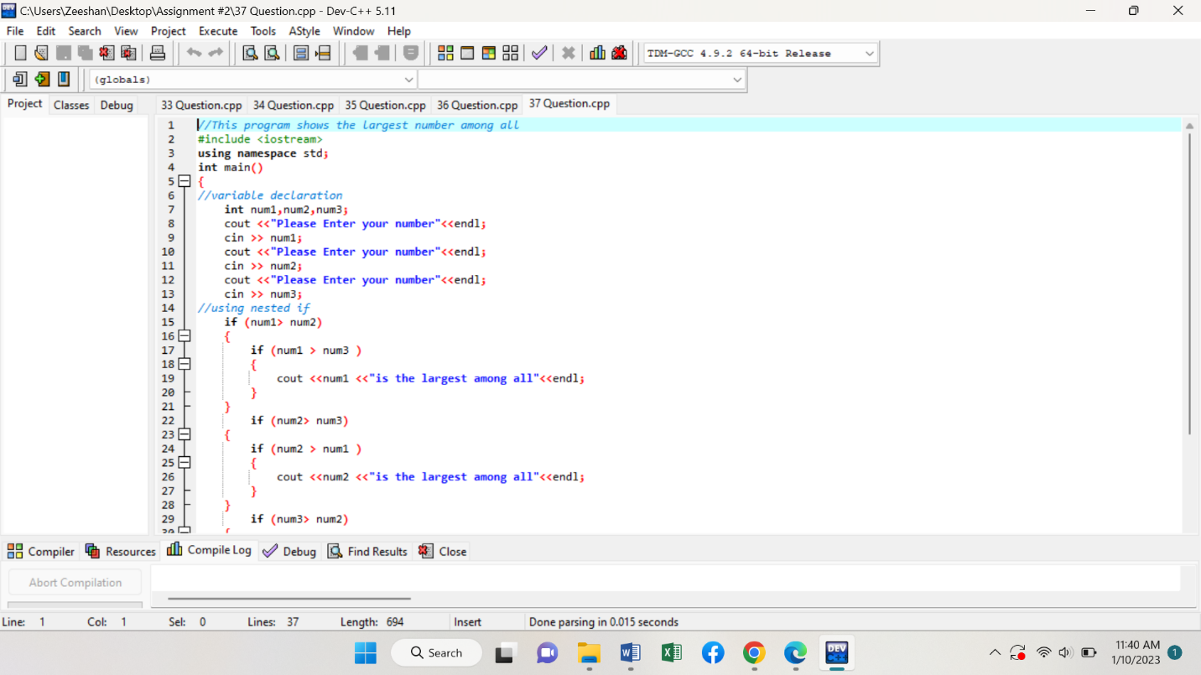

**Another ………..**

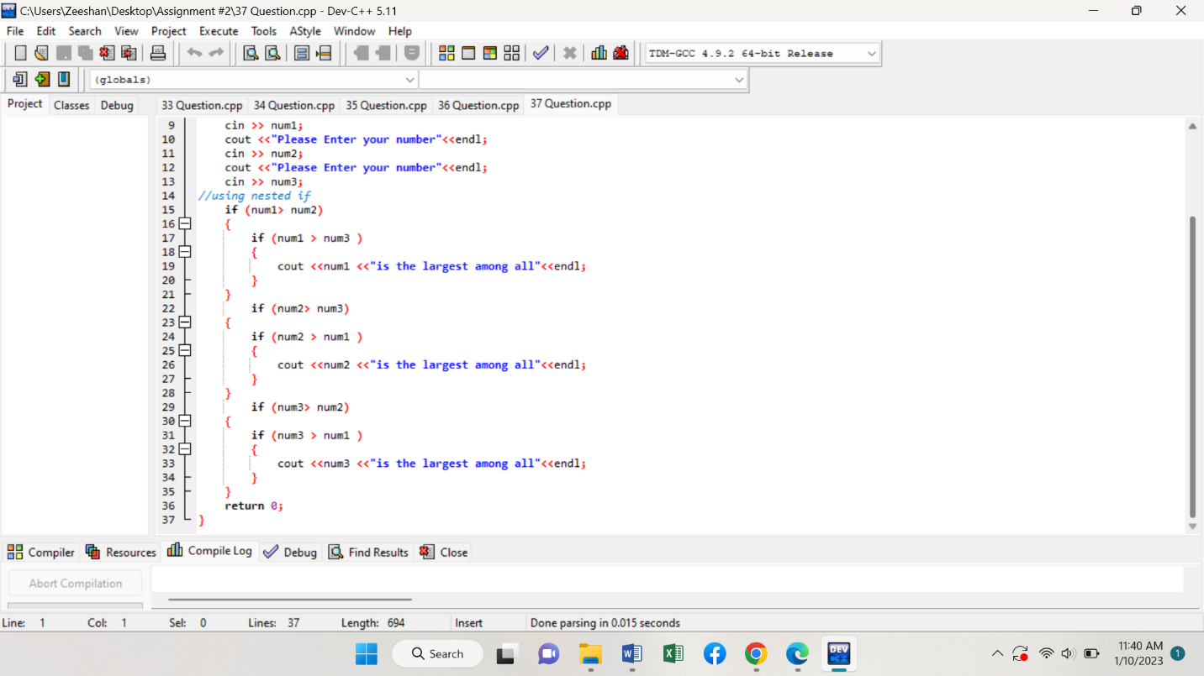

**Program # 37 (Output)**

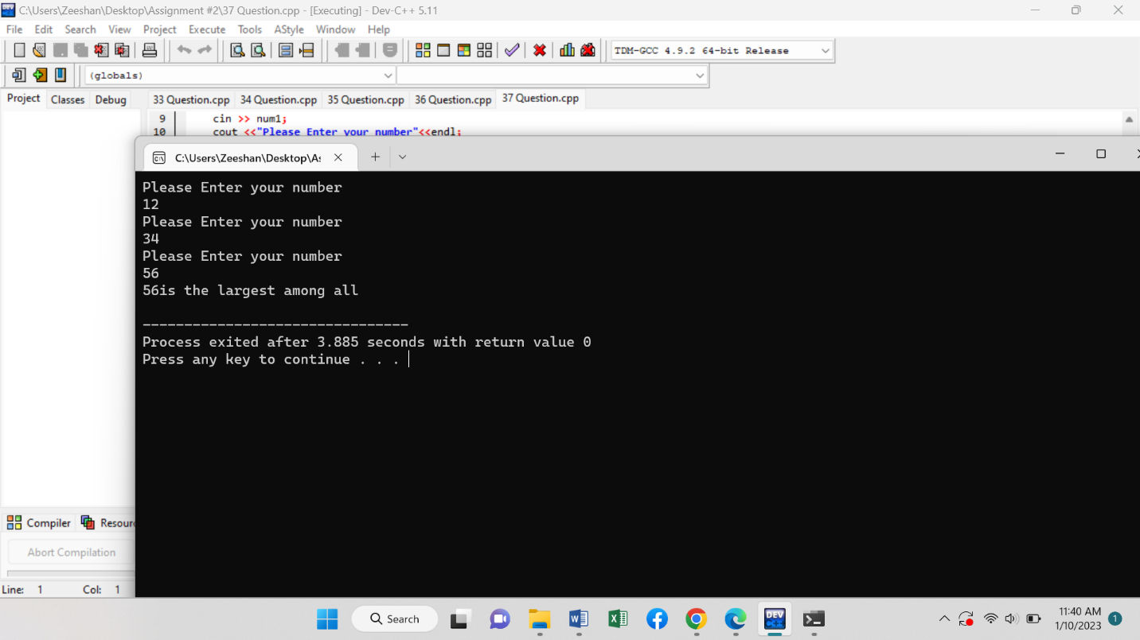

**Program # 38 (Code)**

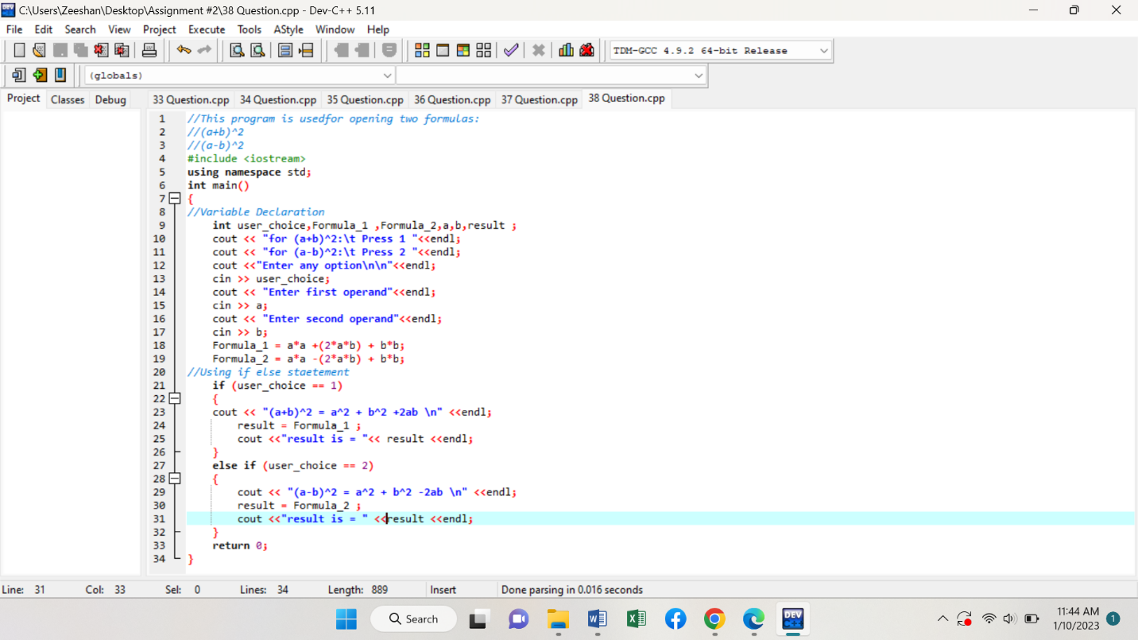

**Program # 38 (Output)**

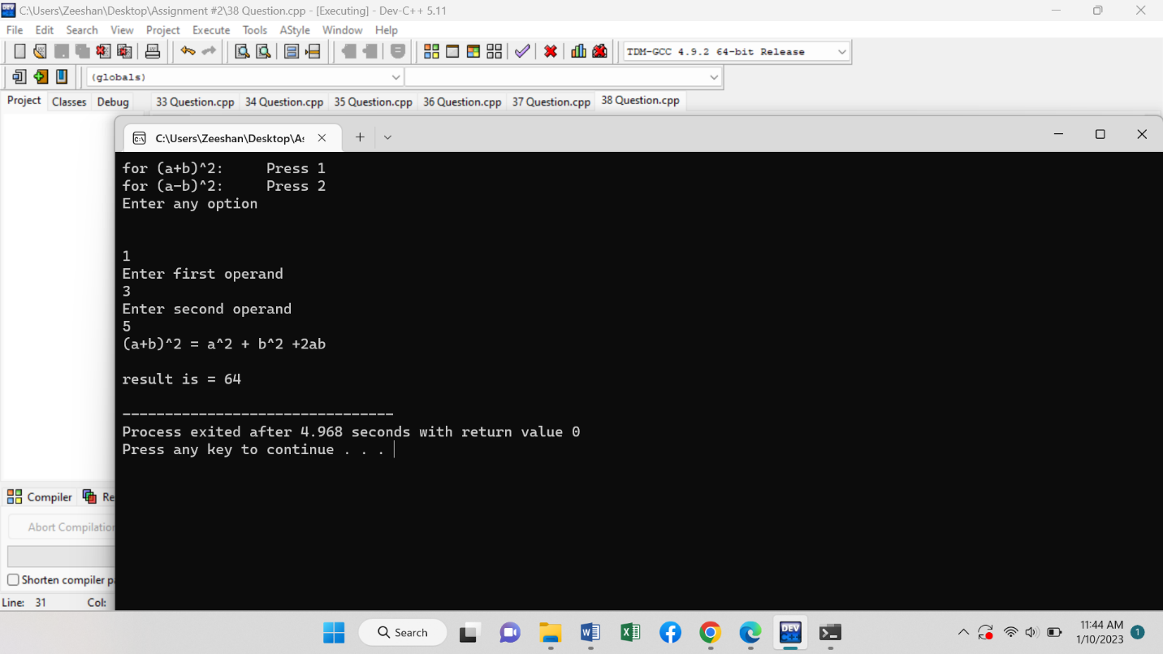

**Program # 39 (Code)**

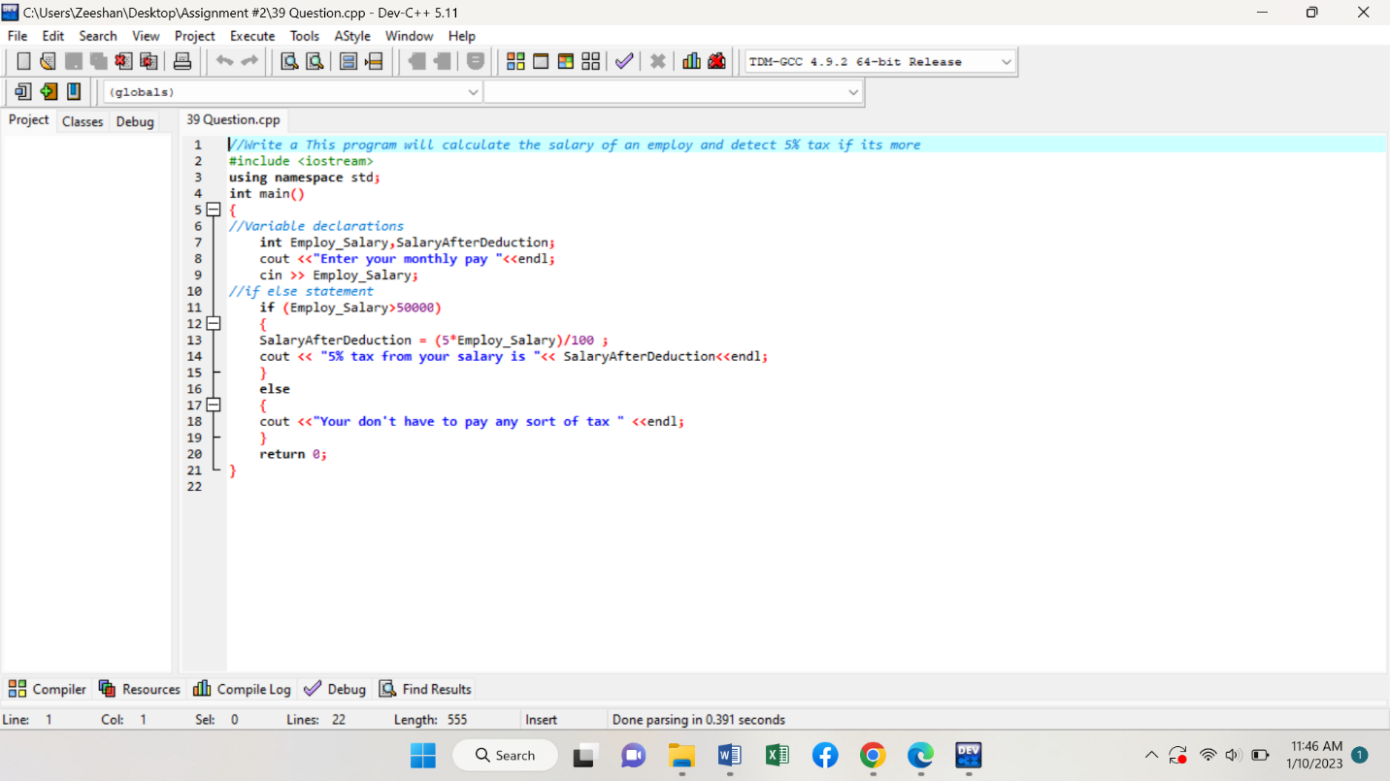

**Program # 39 (Output)**

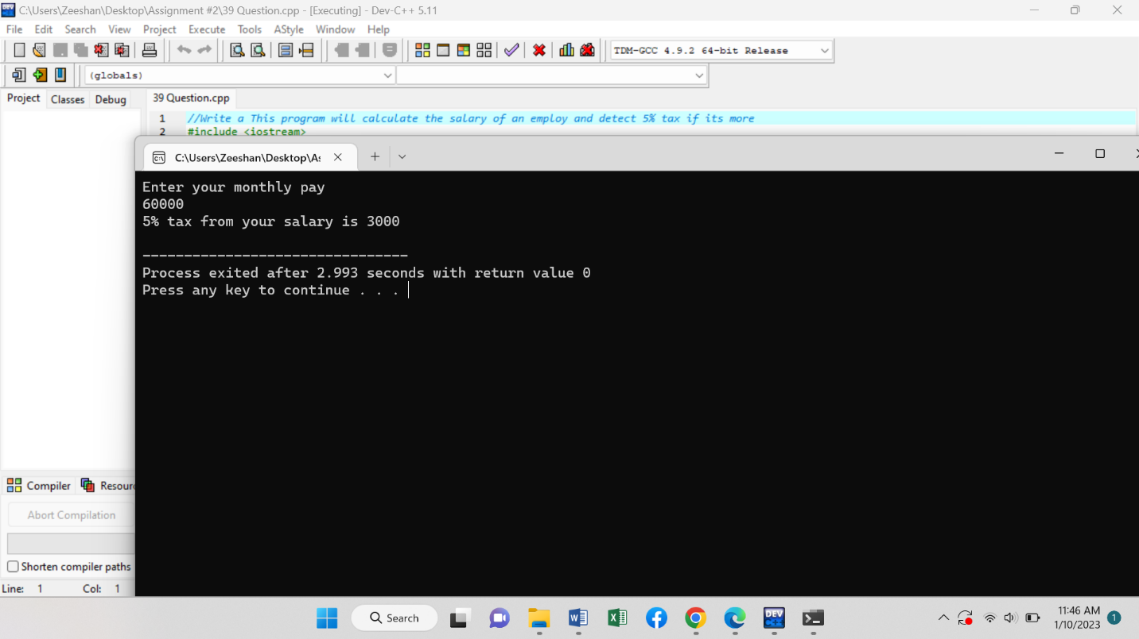

**Program # 40 (Code)**

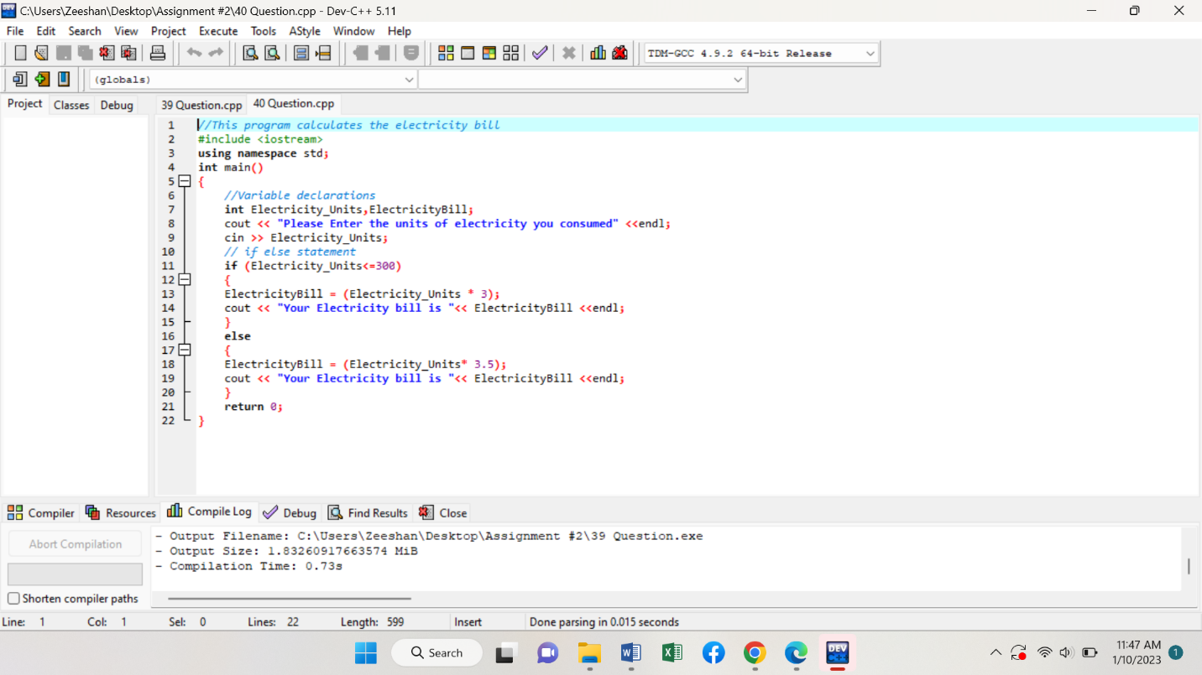

**Program # 40 (Output)**

